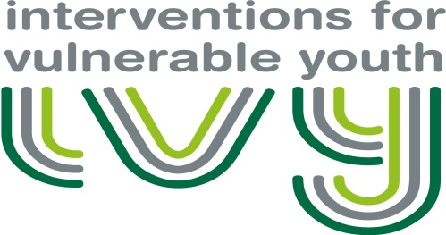
Interventions for Vulnerable Youth
Centre for Youth and Criminal Justice
University of Strathclyde
Lord Hope Building
141 St James Road
Glasgow, G4 0LT
T: 0141 444 8622

REFERRERS CONSENT FORM

Thank you for your referral to the Interventions for Vulnerable Youth Project (IVY). This is a project sponsored by the Scottish Government in conjunction with the Centre for Youth & Criminal Justice (CYCJ), hosted by the University of Strathclyde. As part of the service delivery, we wish to draw your attention to the requirements in respect of data protection, service evaluation and disclosure.

Data Protection
In order to provide referrers with a comprehensive service, there is a requirement to share sensitive and personal information between referrers and the project. At Stage 1 level of intervention consent from the young person is not be a prerequisite for referral, as guidance from the Information Commissioner states that “If information is likely to be shared to safeguard a child’s well-being, the child, family, and/or third party should be only told that appropriate information will be shared if by doing so, the child’s well-being will not be prejudiced and consent should not be offered as an option.” Best practice however would suggest that, where possible, the referral should be discussed with the young person and their parent/carer.
If a young person moves to Stage 2 or Stage 3 of intervention their informed consent will be sought.
Please read our Data Processing Agreement before making a referral to the project.

Service Evaluation
The IVY team will gather and analyse data on the mental health, criminogenic and risk profiles of the young people and we ask all professionals to provide feedback on the utility of the service. The young person should be informed about this. The service is free to professionals across Scotland on the understanding that you complete and return our evaluation questionnaire as soon as possible following the consultation. Please see the Participant Information Sheet for further information.
If a young person moves to Stage 2 or 3 levels of intervention their explicit consent will be obtained to share their information and conduct research.
All information used for the purposes of service evaluation will have obvious identifying information removed (i.e. name / DOB / address) and no outputs from the project , including submissions to Government for audit purposes and research papers, will contain identifying information about participants.

Disclosure
IVY supports high risk young people and we are governed by the practice and professional protocols that apply to all social work and applied psychology practitioners. On occasion, disclosure of personal information may be necessary in order to safeguard the welfare of a young person or a third party. Where this is necessary, the lead professional and referrer will have responsibility for this but in addition, the IVY team will communicate concerns independently in accordance with the service governance requirements.
I agree to the conditions as detailed above

Referrer’s Details: (PRINT NAME) (SIGN NAME)

…………………………………………………………………………….. …………………………………………………………………………….

Date:

……………………………………………………

ID for young person (IVY team to complete) ……………………………………………………………….

Please return to ivy-admin@strath.ac.uk or at:
Centre for Youth & Criminal Justice
University of Strathclyde
Level 6 Lord Hope Building
141 St. James Building
Glasgow, G4 0LT

