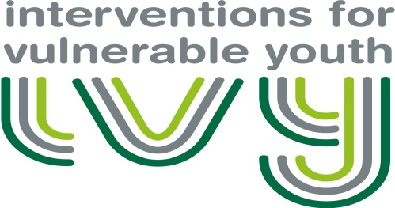
Interventions for Vulnerable Youth
Centre for Youth and Criminal Justice
University of Strathclyde
Lord Hope Building
141 St James Road
Glasgow, G4 0LT
T: 0141 444 8700

REFERRERS CONSENT FORM

Thank you for your referral to the Interventions for Vulnerable Youth Project (IVY). As you know, this is a project sponsored by the Scottish Government in conjunction with the Centre for Youth & Criminal Justice (CYCJ), hosted by the University of Strathclyde. As part of the service delivery, we wish to draw your attention to three issues regarding Data Protection, service evaluation and disclosure.

In relation to Data Protection, for the project to operate successfully there is a requirement to share sensitive and personal information between referrers and the Project. Please read our Data Processing Agreement before making a referral to the project, and best practice would dictate that you discuss this referral with the young person or parent where possible. However, at Stage 1 level of intervention explicit consent from the young person will not be a prerequisite for referral, as guidance from the Information Commissioner states that “If information is likely to be shared to safeguard a child’s well-being, the child, family, and/or third party should be only told that appropriate information will be shared if by doing so, the child’s well-being will not be prejudiced and consent should not be offered as an option.” If a young person moves to Stage 2 or Stage 3 of intervention their informed consent will be sought.

If you agree to proceed on this basis, please print your name and sign and date below:

I can confirm that I have read and agree with the Data Processing Agreement

Referrer’s details: (PRINT NAME) (SIGN NAME)

………………………………………………………………………………. …………………………………………………………………………………..
Date

……………………………………………………………
In relation to Service Evaluation, as we progress with this project, the team will be gathering and analysing data on the mental health, criminogenic and risk profiles of the young people and we will be asking all professionals to provide feedback on the perceived utility of the service. By signing below, you agree to provide this data to the Project and to inform the young person of this. You can choose to opt out of this and further levels of research if you wish (please see the Participant Information Sheet for further information). If a young person moves to Stage 2 or 3 levels of intervention their explicit consent will be obtained to share their information and conduct research. As with any project using personal data, we confirm that any information used for the purposes of service evaluation will have obvious identifying information removed (i.e. name / DOB / address). None of the outputs from the Project (including submissions to Government for audit purposes and research papers) will contain identifying information about participants. If you agree to proceed on this basis, please print your name and sign and date below:

I agree to participate in the full evaluation which will involve the anonymised use of data that I have submitted and also will require me to complete evaluation forms.

Referrer’s details: (PRINT NAME) (SIGN NAME)

……………………………………………………………………………………. …………………………………………………………………….
Date

……………………………………………………………

The third issue concerns disclosure. Since our service exists to support high risk youth, we are governed by the usual practice and professional protocols that apply to all social work and applied psychology practitioners. As such, there may be instances when disclosure of personal information might be necessary in order to safeguard the welfare of a young person or third party. On these occasions, the lead professional/referrer will be expected to take responsibility for this but the project team will also communicate concerns independently as per their governance requirements.

ID for Young person (project team to complete) ……………………………………………………………….

Please return to ivy-admin@strath.ac.uk or at:
Centre for Youth & Criminal Justice
University of Strathclyde
Level 6 Lord Hope Building
141 St. James Building
Glasgow, G4 0LT

