Early and Effective Intervention Champions Group

Short Life Working Group

Training Development Report

February 2014

Introduction

In July 2013 the Early and Effective Intervention (EEI) Champions Group created three short life working groups to take forward the recommendations which were made following the EEI Practitioner Event on 17 January 2013. The focus of the working groups was detailed as follows:

- Core Elements
- Menu of Options
- Training Development

In December 2013 the three groups met to discuss initial reports and feedback on these from the Champions Group. The comments and agreements from these meetings are included in this report.

The Training Development Short Life Working Group was asked to look at current requirements for Training within EEI and identify Existing Courses/Materials and Gaps. We were also asked to provide recommendations as to supporting current and future training requirements nationally.

This report includes details of -
- Further Expansion of the initial consultation (Practitioners Event January 2013)
- Options to address existing/future gaps
- Recommendations from Practitioners about the frequency, location and delivery of National Training for EEI

Further Consultation – More Detailed Feedback from Practitioners

The EEI Development Day held on 8 October 2013 was used as an opportunity to consult further with practitioners about the training needs of all practitioners involved both directly and indirectly in EEI. Practitioners were asked a variety of questions using the PP voting system (an interactive tool to provide real-time responses to a series of questions using keypad options to indicate answers) and following this discussion groups took place in the afternoon to explore particular questions further (see appendix ‘A’ feedback from group discussions).

PP Voting Results

- 78% of practitioners either agreed or strongly agreed that once core elements have been established that staff needed support to learn and develop their knowledge in this area. | 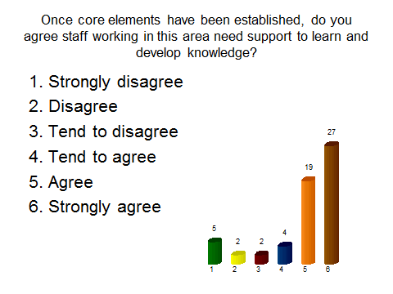
- 25% thought this input should be delivered at a general awareness level, 20% in depth and 56% using a tiered approach. The tiered approach was explored further by practitioners during the group discussion session. | 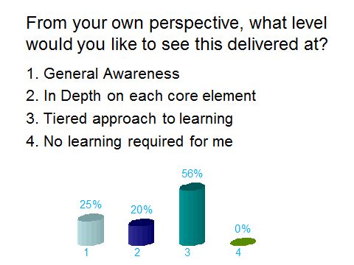
- 47% wanted input for practitioners new to EEI to be in depth on each core element with 36% preferring a tiered approach. | 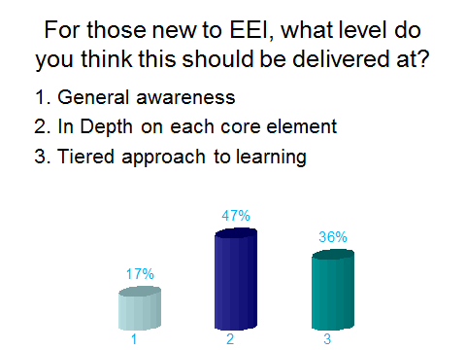
- 32% of practitioners voted for network events to be used to develop knowledge of core elements and 30% preferred the option of short seminars. 16% thought internal packages from their own local authority would be helpful and a further 16% voted for e-learning modules. | 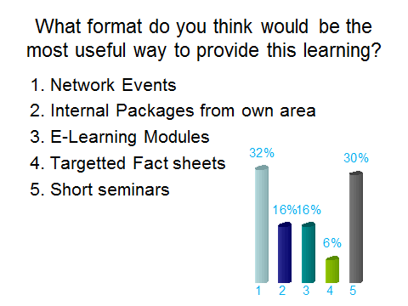
- 70% agreed that input on chairing EEI meetings should be provided. | 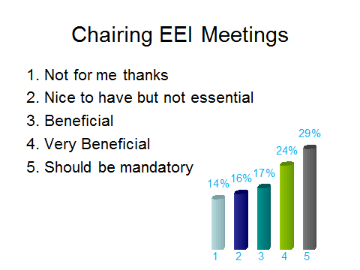

- 85% agreed that input on managing professional difference should be provided. | 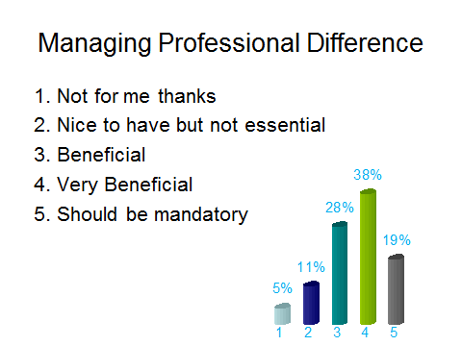
- 89% agreed that input on performance management should be provided. | 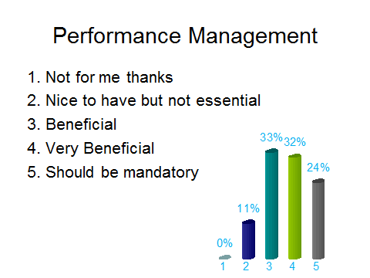
- 94% agreed that input on scrutiny, quality assurance and evaluation should be provided. | 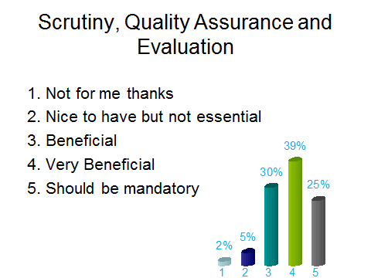
- 94% agreed that input on governance should be provided. | 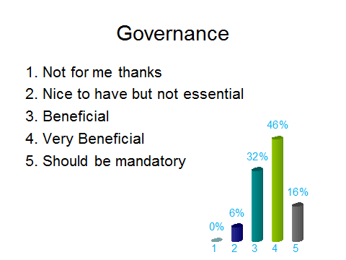

- 100% agreed that input on information sharing should be provided. | 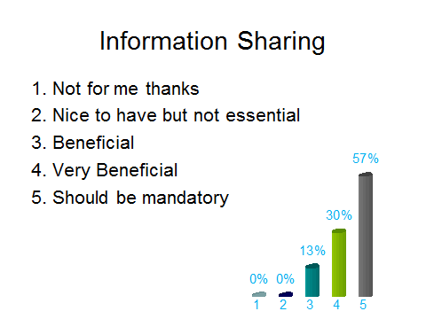
- 100% agreed that input on recording should be provided. | 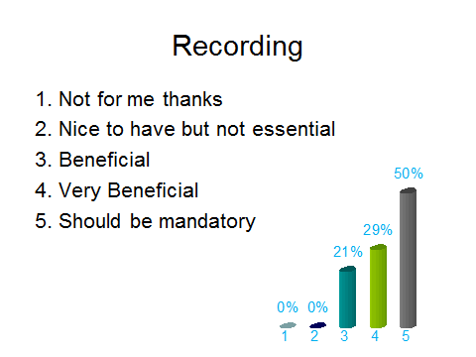

- 90% agreed that input on the named person (GIRFEC) should be provided.
Afternoon Group Workshop

The above results were considered by the subgroup members during the interval at the Development Day. In order to obtain more specific feedback specific topics were selected to generate discussion during the afternoon session and reflect Practitioners needs and explore the training model required.

The following questions were asked and summary of responses noted:

- The tiered approach – how did delegates see this? More than half agreed there is a need to cover all topics relevant to EEI and that input should be available at a very generic level which is suitable for all agencies and practitioners whilst at the other end of the spectrum have training which is specific to EEI co-ordinators and managers/front line practitioners. Several groups highlighted the need for events/training to be pitched at the correct level for the audience.

- The second explored the format of learning - Most groups highlighted the importance of location when arranging training/events. Stirling and Perth were suggested as good central locations for National Events, however there was also a suggestion that the location should move around. It was suggested that National Events should be for one day and local events for half a day and that there is perhaps an opportunity to link these to the Youth Justice Forums/Network Events. One group suggested that a more directive approach nationally would be helpful. Maintaining links between GIRFEC and EEI was highlighted as important.

- Training for Chairs – should it be generic or specific to EEI? The majority of practitioners wanted generic training to assist with chairing meetings as opposed to specific EEI chair training.

- Performance management and what training in that area should entail - Most groups agreed that performance management was more than statistics and trends. Groups highlighted the importance of gathering accurate information, and identifying outcomes (not just re-offending rates). Most groups identified that training in performance management should be aimed at various levels and not just EEI practitioners.

A predominant theme was that the training should avoid the use of the term “EEI coordinator” as this is interpreted differently across the country. Rather focus should be for those practitioners in a co-ordination or management of the operations/function of EEI roles including resource allocation. It is recognised that these may be the same people but they also may not be. It appeared to be generally felt it should be up to decision makers to decide who is relevant to attend what training.

Another theme highlighted was that any training should not duplicate or conflict with existing training programmes, such as GIRFEC.

Finally, the Practitioners felt the National Development Team’s fact sheets and newsletters should underpin and support any training provided.

Recommendations

The EEI Champions Training Development Short Life Working Group members had attended both the January 2013 Practitioners Event and the October 2013 Development Day and the overarching message was clear from those who work in EEI either as a manager, service provider or practitioner that they did want Training/Awareness Raising events. For the purposes of this paper the term training has been used, however it is recommended that input should be a mix of training and awareness raising. There was recognition that nationally EEI processes, partners and structures vary greatly depending on interpretation of existing/historical guidance and was different with regard to resource and impetus attached by executive policy makers across Scotland.

The additional consultation at the Development Day has allowed the group to gain a fuller understanding of what Practitioners feel they need as regards training to assist with achieving awareness and understanding of EEI processes and eventually work towards a more consistent approach nationally within existing structures and resource.

The following list of recommendations if implemented could address a significant desire to achieve Training/Awareness Raising Development within the arena of EEI:

WHAT type of training/awareness?

- A tiered approach to training should be adopted. It will not be possible to accommodate all the individual or agency wish lists for Training in EEI but from the feedback a substantial number felt the training could be tailored from a general awareness and understanding for all agencies and also specific to post/role within EEI. Our recommendation extends the feedback to suggesting the training could be separated into Initial Induction Course explaining the key aspects of a role in EEI, then another package which could be used as an Awareness of EEI for individuals or agencies who may have a part to play in EEI but is not their only role or key responsibility e.g. Education. Finally there is also a need to extend awareness of EEI to Strategic Management within agencies which could inform Senior Managers of the work done in EEI and how it supports their shared objectives including as part of GIRFEC. This could be achieved by an update, endorsed by the Scottish Government, being sent to all relevant strategic managers in each local authority. Consideration should also be given to this information being disseminated to local community planning partnerships.

- The feedback indicated the training should include:

- Implementation of Core Elements of EEI, Minimum Standards and Menu of Options
- Information Sharing and recording (who, what, where, how and when)
- Managing professional difference and the Chairing of meetings – which practitioners should not just be specific to EEI and WSA
- Performance management training was an area where training and guidance was being sought and it should consist of: Data Input, Data Collation and Interpretation/Analysis of the data. This training particularly could be tailored to skills and need.
- Any EEI training developed and provided should not duplicate or conflict with existing training programmes such as GIRFEC.
- Creating sustainable services to ensure they are robust enough to continue following changes in personnel.

HOW can we train, WHERE is it delivered and deciding WHO needs to be trained:

- The preferred model of delivery of training appeared to be National Network Events in a central location. This was surprising to the Short Life Working Group but it is clear that Practitioners gain collective support and knowledge from their colleagues across the country allowing for further development and sharing of experiences in EEI.

- Local events could be arranged dependant on the Single Agency or Multi Agency Partnership needs.

- Application processes could indicate the right people are getting the right training at the right time. The working group feel that this is a national co-ordination task which may sit with CYCJ to facilitate.

- Twin tracked approach - input should be a mix of training and awareness raising.

- The National Development Team fact sheets and newsletters should underpin and support any training programme/package developed.

- The training should be linked to the National Training Strategy which is agreed by the Centre for Youth and Criminal Justice (CYCJ) and Scottish Government.

Appendix A – Afternoon Group Workshop – Practitioner Comments

GROUP A
Question 1
- Appropriate training for your involvement in EEI
- Performance management/ Info sharing
- Practice – Group co-ordination
- General aware of EEI – Schools Community Police
  - Youth Work etc
- Some people need to know all
- Initial training for a tiered approach could be given to Police/schools/community/however EEI co-ordination needs more training/EEI group needs more training

Question 2
- Interactive Network Event – Yearly/Quarterly
- Linking into Youth Justice Forums
- Build up the Networks/ share good practice

Question 4
- Performance Management
- Input – Output – Outcomes
- Every intervention detail outcomes and measure progress
- Training for all

GROUP B
Question 1
- Tiered approach to learning/knowledge development
- Strategic and operational approach. Frontline staff not directly involved in EEI basic awareness.
- Staff involved in EEI high level training. This tiered all the way up to senior managers/decision makers in order that representation from all services is consistent and sustained.

Question 2
- Events need to be mindful of audience and pitch to the correct level.
- Location of events to be moved around.

Question 4
- Performance Management. National performance stats – EEI co-ordinator administrator.
- Local stats – indicate need for local response/training (gathered by seniors involved in EEI).

GROUP C
Question 1
- Who is the audience
- What knowledge/detail is required
- Needs to be tailored to participants
- Participants can opt in to the level they need

Question 2
- National training events (better food please)
- Central location e.g. Perth
- Rotational basis
- 6 monthly
- A forum to feed into suggesting which topics for training would be helpful

Question 4
- Patterns, trends and stats (No)
- Implementation of records
- Who should be trained
- Potentially a management roll (strategic Multi Agency)
- Training should be provided to managers in order to analyse information gathered and implement change

GROUP D
Question 1
- Tiers of an operational point of view and a strategic point of view
  - Operational – people on the ground
  - Strategic – management and leadership

- Agency specific training and multi –agency
- Huge awareness need
- GIRFEC Training/Youth Justice Training

Question 2
- Don’t cram too much into one day, one subject at a time. Specific subjects
- Collaboration between GIRFEC and EEI
- Location – various, Road shows, Divisional
- Training specific to your own local authority
- Awareness sessions across the agencies

Question 4
- What is performance management? Agree, patterns, trends and stats
- Representatives from each agencies should be trained

GROUP E
Question 1
- Never understood original question
- Different levels – Basic – Advanced
- Options for training that you could choose appropriate to your need (coding system 1-5 etc)
- Appropriate people delivering training i.e. skills set appropriate to subject/level
- Training needs to be Multi-Agency, across partners
- Possible EEI Champions – Internal training for departmental awareness

Question 2
- Regional as opposed to national, perhaps by council area
- With a yearly national event
- ½ day for local events, 1 day for national
- Topics need to be planned in advance
- Multi-Agency better
- Frequency – minimum quarterly
- Better use of other meetings i.e. Youth Justice forums

Question 4
- Bigger than stats and trends
- Really about info gathering and identifying outcomes
- It’s the whole picture (Grace says 08/10/2013)
- Training required for all levels, management, admin, practitioners
- Why – what’s use for info?
- Lack of system compatibility, SW/Police etc
- Identify your sources of info.

GROUP F
Question 1
- Co-ordinator may need more input i.e. booklet of training, e-learning no always helpful
- Information gap on what is EEI? – centralised approach
- Fact sheet
- Interactive network events

Question 2
- Frequency/Content/Geographical location
- National – more directive. Looking at national picture
- Shared learning – sharing each agencies role and expectations of each other
- EEI Co-ordinators course at Jackton
- Clarity of disclosures

Question 4
- Establish performance criteria
- No of Y.P. referred
- No of referrals to reporter
- Demonstrate good outcomes e.g. each disposal must demonstrate one GIRFEC outcome
- Group V individual input

GROUP G
Question 1
Most Specific
EEI Co-ordinators

Managers/front line practs direct work

All agencies

Most general/overview
- EEI Co-ordinators need training/skills/knowledge to undertake the task
- Managers of front line staff and front line staff and attendees at Multi-Agency group need tailored training to deliver EEI
- Wider partners need a general awareness to understand where from and why they are receiving these referrals

Question 2
- Content
- Frequency
- Where
- Location
- What
- When
- Local vs National

- National events
  - decent lunch
  - Bi-annual national AND Bi-annual Local
  - E.g. National then local then national then local with YJ conference in the middle of the year
- Stirling viewed a good location
- New ideas for practice
- What is working
- Overcoming issues

Question 4
- Who should training be aimed at
- Too many stats
- Be for everyone to ensure you are accurately collating
- What are we measuring – over what timescales
- What training looks like
- Who is delivering training
- Training on the Data Standards – How do we monitor them when our service ends
- Be realistic about what agencies CAN record
- Accessing information e.g. are they on CSO/S70

