# Children and young people in custody in Scotland:

# looking behind the data

**Acknowledgements**

This paper has been developed by Dr Gill Robinson (Scottish Prison Service (SPS)), Jenny Leishman (Scottish Government Justice Analytical Service) and Dr Claire Lightowler (Centre for Youth & Criminal Justice (CYCJ)) on behalf of the Youth Justice Improvement Board (YJIB).

The Youth Justice Improvement Board was set up by the Scottish Government to promote the implementation of the Youth Justice Strategy ‘Preventing Offending: Getting it right for Children and Young People’, which was published in June 2015.

The YJIB is made up of representatives from the Convention of Scottish Local Authorities; Scottish Children’s Reporter Administration; Children’s Hearings Scotland; Education Scotland; Crown Office and Procurator Fiscal Service; Police Scotland; Child Health Commissioners; Includem; Action for Children; Social Work Scotland; National Youth Justice Advisory Group; Scottish Association of Local Authority Chief Executives; Community Justice Scotland; Scottish Courts and Tribunal Service; CYCJ; SPS and the Scottish Government.

The authors would like to thank all those who helped with preparation of this paper: Carla Cesaroni, Debbie Nolan and Fiona Dyer for permission to quote unpublished data, colleagues in Scottish Government who undertook the mapping, SPS colleagues who assisted with the analysis of data, CYCJ colleagues who offered comments and Charlotte Morris for proof reading and communications. We also wish to thank the children and young people in custody who shared their experiences.

# Children and young people in custody in Scotland:

# looking behind the data

## 

This paper has been produced at the request of the Youth Justice Improvement Board to encourage reflection about children and young people in the justice system in Scotland, particularly those who are detained in custody. It is intended for all who provide services and support to vulnerable children and young people, including those who come into contact with children and young people in the justice system. By offering insights into what we know about these children and young people and what is happening within youth justice the paper seeks to provide a basis for discussions to inform improvement.

**Introduction**

Children and young people who are involved in offending come into contact with the youth or criminal justice system in a variety of ways depending on their age, their needs and circumstances, and the nature of their deeds. Information about the different stages in the system is available through [Youth and Criminal Justice in Scotland: the Young Person’s Journey](http://content.iriss.org.uk/youthjustice/). Both the lives of these children and young people and the ‘system’ that engages with them are complex. This means that it can be extremely difficult to understand what is actually happening for these children and young people, and also that there are rarely easy answers to guide how best to respond to their offending behaviour.

This paper has an emphasis on children aged 16 and 17 who are detained in custody but also includes references to young people aged 18 to 21, whose circumstances are often very similar to those of the younger age group. We use the term ‘children’ to refer to those under 18 years old and ‘young people’ when referring to 18-21, in keeping with the [United Nations Convention on the Rights of the Child](https://downloads.unicef.org.uk/wp-content/uploads/2010/05/UNCRC_united_nations_convention_on_the_rights_of_the_child.pdf?_ga=2.110213889.509515872.1495023093-155645293.1495022993) (UNCRC).

The paper focusses on three themes:

1. Backgrounds of children and young people involved in offending
2. Children and young people’s contact with the justice system, especially those who are sentenced to custody
3. What happens after custody?

The paper has been produced in partnership between the Centre for Youth & Criminal Justice (CYCJ), the Scottish Government and the Scottish Prison Service (SPS). The information is drawn from a number of sources including research papers and data from the Scottish Government’s Criminal Proceedings Database and the Scottish Prison Service. It incorporates the story of ‘Danny’, whose experiences represent very many of the young people now in custody. The paper can be added to and strengthened as we learn more.

The data, particularly that relating to custodies, is complex and includes a number of illustrative snapshots which may not be fully representative. We would therefore encourage caution in drawing any further conclusions than those which are drawn in this paper. Instead, we highlight areas for further reflection and exploration in each section of the paper.

### **1. The lives of children and young people involved in offending**

It is important to recognise that nearly all children commit a minor offence at some point in their childhood (a minor offence means, for example, stealing from their mum’s purse, doing graffiti or getting into a low-level fight at school). The Edinburgh Youth Transitions and Crime study found that 95% of children did so (McAra and McVie, 2010). The offending of some children can become more frequent and serious, however, involving contact with the police and other youth justice agencies. In 2012-13 just under 5% of children in Scotland came into contact with the police for their offending behaviour (Scottish Government, 2013).

### **Backgrounds of children and young people involved in offending**

There is growing evidence that children involved in a pattern of offending behaviour are some of the most vulnerable. The Edinburgh Youth Transitions and Crime study revealed that 15 year olds involved in violent offending were significantly more likely than their non-violent peers to be victims of crime and adult harassment, be involved in self-harming and para-suicidal behaviour, have problematic health risk behaviours, have weak bonds (particularly to parents and school), have personality issues (particularly impulsivity and risk taking), have been involved in bullying others, have experienced family turbulence and social deprivation, and have friends involved in offending (McAra and McVie, 2010).

*Danny says that his early childhood was a happy one.*

*Both his parents have long-standing problems with alcohol. Social workers were concerned for several years about how his parents were setting boundaries for his behaviour. His parents separated when he was 11 and Danny then went to live with his father.*

Similarly, in looking at the backgrounds of 100 children under 12 years old referred to the Children’s Reporter on offence grounds, there were 37 children where the offence was part of a pattern of behaviour. Of these 37 children, 30 had parents who presented risks to them, 26 had educational problems, 16 had mental health difficulties and 11 had been the victims of physical or sexual abuse (Henderson et al, 2016).

**1.1.1 Adverse Childhood Experiences (ACEs) of Children in Secure Care**

ACEs are currently an area of increasing interest in both policy and practice. For young people who are looked after and accommodated in foster care, residential units or secure care, a difficult childhood is even more apparent than within the wider community. Research by Kibble Education and Care Centre found that the children admitted to their service had extremely high levels of ten well-documented categories of Adverse Childhood Experiences (ACEs): emotional abuse, physical abuse, sexual abuse, emotional neglect, physical neglect, domestic violence, household substance misuse, household mental illness, parental separation/divorce and household imprisonment. More than one-third of the boys and half of the girls had experienced six or more of these issues. At least 50% of the children at Kibble had experienced emotional abuse, emotional and physical neglect, violence in the family, and parental separation/ divorce.

*Danny was involved in offending from age 13, including vandalism, dishonesty and violence, generally while he was under the influence of alcohol and involved with a negative older peer group. His first involvement with the police was when he was 13 and he was given a Police Restorative Justice Warning for Assault.*

Although children in secure care units in Scotland are more likely to be there because they are at risk from other people and/or from themselves rather than because they pose a risk to others, both groups tend to have similar life experiences.

* 1. **What do we know about the life experiences of children and young people in custody?**

**1.2.1 Care experience and contact with Children’s Hearings system**

Of the 327 young men under 21 in HMYOI Polmont who responded to the Scottish Prison Service 2015 Prisoner Survey, a third (33%) reported being in care as a child and a quarter were in care at the age of 16 (Broderick and Carnie, 2016). To set these figures in context, fewer than 2% of Scotland’s children (15 317) were being looked after on 31 July 2016 ([Scottish Government, 2017).](http://www.gov.scot/Publications/2017/03/6791)

In a recent study of 103 young offenders at HMYOI Polmont (Cesaroni, 2017), three out of every five young people who were interviewed indicated that their family had been involved with the Children's Hearings system and one third (33%) reported being removed from their family and placed in supported accommodation. The close relationship between child welfare involvement and likelihood of criminal justice involvement is well known (Ryan and Testa, 2005; Grella et al, 2005).

*Danny was looked after for nine months when he was 15. This care placement was with a residential service and was on a voluntary basis. The period of care stopped three months before his 16th birthday. He absconded several times from his care provider.*

From interviews with 14 young people in HMYOI Polmont, Dyer and Nolan found that 11 reported a history of social work involvement and eight reported that they had been removed from their parent’s care, although there was an evident level of uncertainty about what being ‘care experienced’ meant. Eleven stated that they had previous involvement with the Children’s Hearing System (CHS), although they were not always clear about the outcome of this involvement. None of the young people were currently subject to measures via the CHS, with half commenting that their Compulsory Supervision Order (CSO) had been terminated just prior to or very shortly after their 16th birthday. In many instances young people recalled that offence cases were still outstanding or a serious offence was committed very quickly after this order was terminated. Six of the respondents had previously been in secure care (Dyer and Nolan, forthcoming).

**1.2.2 Bereavement**

Research into the life experiences of 33 young men under 21 years old who were in HMYOI Polmont found that almost all had been bereaved and more than three-quarters had experienced traumatic bereavement (murder, suicide or drug overdose) in their family or amongst their close friends.

Two-thirds had suffered substantial bereavement (four or more). The presence of multiple and traumatic bereavements can complicate how young people manage their grief, often leading to angry and aggressive outbursts, or self-medication with substances (Vaswani, 2014).

**1.2.3 Exposure to trauma**

In Cesaroni’s study, participants reported multiple types of trauma exposure. This included both direct trauma, or as witnesses or vicarious exposure to a traumatic event. Young people reported being sexually (10%) or physically abused (15%), fearing that they or someone close to them might be badly hurt (58%), being physically assaulted/beaten badly in the community (64%), threatened with a weapon (76%), witnessing serious violence in the neighbourhood (74%), and witnessing violence in the home (22%). The vast majority of young people reported more than one traumatic event (Cesaroni, 2017). Exposure to traumatic events is likely to qualify at least some of these young people to a post-traumatic stress disorder (PTSD) diagnosis. Research suggests that there is an association between child maltreatment and PTSD (Moore, Gaskin, Indig, 2013).

Research also suggests that exposure to traumatic events not only increases the likelihood of a PTSD diagnosis, but may also confer additional mental health risk (Wilson et al, 2013). If trauma is left unresolved, in addition to possible PTSD and mental health issues, negative residual effects may also include drug and alcohol use, and involvement in violent activities (Crimmins et al, 2000).

**1.2.4 Head injury**

In the same study (Cesaroni, 2017) over a third of the young people reported that they had experienced a head injury and a fifth had experienced two or more head injuries. Almost a quarter of young people who had experienced head injuries noted that they received the head injury because of fighting (with bricks, bottles, baseball bats, golf clubs, hammer etc).

It is not known how many of these head injuries led to injuries of the brain, but the mechanism of injury would indicate that at least some of these incidents will have resulted in brain injury. The brain develops rapidly during childhood, adolescence and young adulthood, its connections shaped and strengthened by experience (see, for example, [Savage](http://www.internationalbrain.org/articles/the-developing-brain-after-tbi/), 2012). An injury to the brain before these areas are fully developed may mean they never entirely evolve. Indeed it may be that skills which are developing at the time of injury may be the most vulnerable to disruption. The consequences of brain injury include loss of memory and concentration, decreased awareness of one's own or others' emotional state, poor impulse control and poor social judgment. Unsurprisingly, behavioural problems may be prevalent in people with traumatic brain injuries (TBIs). Young people offend for many reasons and it is difficult to identify a clear causal link between TBI and offending. Adolescence is marked by increased risk taking, which may lead to a greater likelihood of breaking rules. Those who take risks are also more likely to suffer a TBI, so it is difficult to ascertain if having a TBI actually causes someone to offend or whether it is because they are more likely to take risks and therefore suffer a TBI. There is mounting evidence to suggest, however, that TBI may, to some extent, increase the chances of offending due to the actual injury.

Other research (British Psychological Society, 2015) points to higher incidences of foetal alcohol spectrum disorder and traumatic brain injury amongst young people in custody than in the population as a whole.

Dyer and Nolan (2016) noted that almost all of the young people they interviewed reported multiple experiences of and exposure to: loss; bereavement; abuse; homelessness; mental health difficulties; trauma; substance misuse; sibling involvement in offending; family breakdown; parental ill health; and parental inability to cope. Moreover, half of those interviewed displayed comprehension and understanding difficulties, and speech, language and communication needs, in some cases at a level that the researchers deemed to be significant.

***Points for reflection:***

* *Is there more that could be done to support children at an earlier stage, when it first becomes apparent that they are experiencing trauma, abuse or bereavement, and reduce the likelihood that they will offend (and, for some, go into custody)?*
* *Should our current focus on ACEs be extended to encompass other types of trauma which appear to be prevalent amongst high risk groups of young people?*

### **Geography and deprivation**

The map below shows the postcode of residence (where available) for a sample of 16 and 17 year olds in custody during 2016. All eligible individuals present in HMYOI Polmont on one day in each of the months of January, February, April & May were included in the analysis.

**Figure 1: Residences of children aged 16 and 17 in custody based on snapshots of postcodes**



*Source: Scottish Prison Service, Based on four snapshots (Jan, Feb, Apr & May 16) Map – Scottish Government Geographic Information Science & Analysis Team*

The map shows that children detained in custody came from communities across Scotland, although predominantly in the central belt. It can be seen that there are only a few postcodes where there was more than one individual in custody at the time of the snapshots, indicating a greater spread across communities than is sometimes believed based upon previous analyses of the prison population.

Figure 2 shows how these postcodes map to Scottish Index of Multiple Deprivation (SIMD) scores and illustrates the relationship between levels of deprivation and detention in custody.

**Figure 2: Distribution of residences of young people in HMYOI Polmont by Scottish Index of Multiple Deprivation (SIMD) deciles**

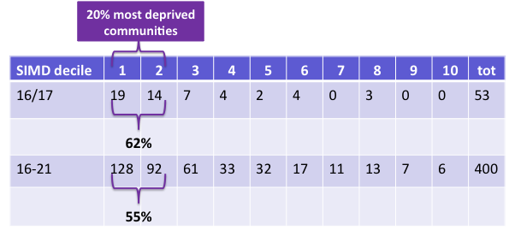

*Source: Scottish Prison Service*

The highest numbers of young people in both age ranges were from the most deprived 10% of communities (decile 1), with almost two-thirds of the 16 and 17 year olds and over half of 16 to 21 year olds living in the 20% most deprived communities in Scotland. That said, there were also young people in custody (mostly under 21 year olds) whose communities are amongst the least deprived.

Analysis of the information on geography and deprivation can enable us to explore whether there are communities which may be working more successfully with children and young people to help them to manage their lives and keep clear of offending. This may be related to the strengths and assets of these communities, such as where schools rarely exclude children (see below) or where there are strong preventative or youth justice focused initiatives. However, the numbers are small and each case is individual, and we need to be cautious about assuming correlations between macro issues, such as deprivation or local practices, and individual behaviours: a range of complex societal, cultural, environmental and personal factors is likely to come into play in each case.

***Points for reflection:***

* *Are there some communities which have lower rates of offending than you would think likely given their levels of deprivation and social issues? If so, what factors and practices might be leading to success in reducing offending/supporting children and young people?*
* *Similarly why might certain areas have higher levels of offending than their context and background would suggest?*
  1. **Exclusion**

The association between offending and deprivation does not mean that poverty causes offending, since most young people who live in families who struggle with finances do not get involved in offending at all. But poverty can be an indicator of wider exclusion: exclusion from opportunities and protective factors that help young people resist and desist from offending throughout the life course.

In particular, there is a well-documented correlation between offending and school exclusion, with the Edinburgh Study of Youth Transitions and Crime identifying school exclusion as one of the key determinants for future involvement in offending. This remained true even when compared to children who had committed equally serious and frequent offences who had not been excluded from school (McAra and McVie, 2010). This study also found that early school exclusion was one of the strongest predictors of making the transition from the Children’s Hearing System to the adult criminal justice system and of ending up in custody, even taking other factors such as offending behaviour into account. School exclusion before age 12 increased the odds of imprisonment by age 22 by a factor of four. More recently, research conducted by CYCJ found that 80% of a sample of young men in HMYOI Polmont had experienced exclusion from school (CYCJ, 2014) and, of the young people who responded to the SPS Prisoner Survey of Young People in Custody (2013), 90% reported that they had been excluded from school, 42% on four or more occasions.

Recent narrative evidence, including from young people in HMYOI Polmont (Youth Justice Improvement Board, 2016), illustrates the impact that school exclusion had had on them and its connections with their offending. They described the powerful effect of peers - especially the influence of older young people - while they were excluded, and the sometimes rapid escalation of substance abuse, violence and offending at that time. They spoke of the impact of broken connections with school but also with out-of school activities and the role models and pro-social pastimes such as football, which that wider community can provide. After exclusion, very few of these young men and women reported having made a successful return to their mainstream secondary school.

*Danny was excluded from school when he was 15 because of truanting, fighting and general misbehaviour. He went to the residential service at that time and did not return to his school.*

The rate of school exclusion is also affected by other forms of disadvantage. For example, the rate of exclusion is four times higher per 1000 pupils for those who have an additional support need (ASN) compared with those who do not, and six times higher for pupils living in the 20% of areas associated with most deprivation (as defined by SIMD), compared with pupils living in the 20% associated with least deprivation (Scottish Government, 2015).

***Point for reflection:***

* *Given what we know about the association between offending and school exclusion, is there more that could be done at an earlier stage to keep the child or young person included in school?*

**2. Children and young people’s contact with the justice system**

**2.1 Trends in offending over time**

Over the last 10 years we have seen a dramatic reduction in the level of offending by children and young people in Scotland. This trend mirrors that seen elsewhere (see for example Bateman, 2015). Referrals to the Scottish Children’s Reporters Administration (SCRA), court prosecutions and sentences have all followed the same downward trend over the last 10 years.

**Figure 3: Trends in custody, court prosecutions and referrals to the Children’s Reporter for children and young people** *-* **2006-07 to 2016-17**

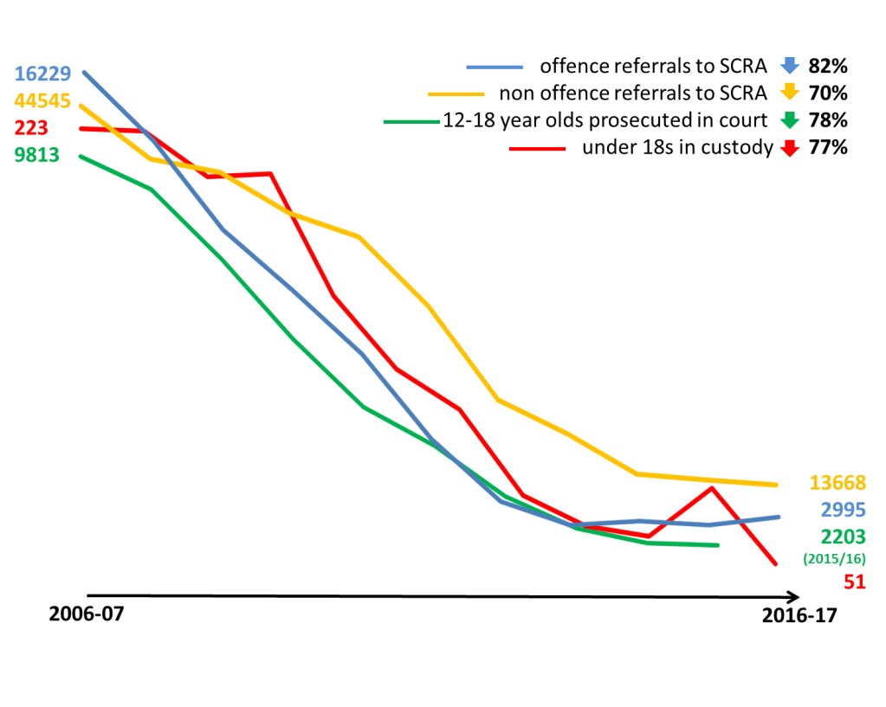

*Source: Scottish Government Analytical Services*

**Table 1: Numbers of children and young people convicted in court per 1000 population in 2006-07 and 2015-16**

|  |  |  |  |  |  |  |
| --- | --- | --- | --- | --- | --- | --- |
|  | **2006-07** | | | **2015-16** | | |
|  | Male | Female | All | Male | Female | All |
| 16 and 17 year old | 116 | 14 | 66 | 26 | 3 | 15 |
| 18 to 20 year old | 176 | 23 | 100 | 68 | 12 | 41 |

*Source: Adapted from Criminal Proceedings Database, Scottish Government*

Per 1000 population, the number of 16 and 17 year olds convicted in court reduced by 78% over this period.

The reasons behind the reductions in reported offending and conviction rates are not fully understood, but are likely to be complex combinations of factors. These factors may include changes in young people’s behaviour, environmental and technical changes affecting the types of lower level crimes that young people have traditionally been involved in, changes in support available to children and young people and changes in the types and levels of response from the justice system.

**2.2 Population of children and young people in custody: trends over time**

The graph below shows the numbers of young people under the age of 21 and those aged 16 and 17 in custody in Scotland on 30 June of each year since 2002.

**Figure 4: Numbers of young people in custody in Scotland at 30 June each year 2002-2017**

*Source: Scottish Prison Service*

The experience of custody can be a stressful, overwhelming and disorientating experience, requiring readjustment to a new life regime, becoming familiar with a new environment and renegotiating relationships. A period of custody may be sufficient to disrupt the child or young person’s life, the consequences of which often go far beyond the sentence imposed, but may also be insufficient to help them address outstanding issues and needs that are often linked to their offending behaviour (Social Exclusion Unit, 2002; Malloch, 2013).

It is therefore encouraging to see the marked reduction in these figures since 2009, from a total of around 1300 in June 2009 to 357 in June 2017. Similarly, the number of 16 and 17 year olds in custody has been decreasing since 2006 and is currently around its lowest level since 2002. As with the trends in offending and convictions, the reasons are likely to be complex combinations of factors.

When we look more closely at the numbers of children under 18 in custody over time, we see variation, and peaks and troughs throughout each year alongside the declining trend. This ‘noise’ is a feature of the relatively small numbers involved, and highlights the importance of looking at aggregated trends and being cautious of daily snapshots. Figure 5 shows the total custodial population aged 16 and 17 together with the numbers who were sentenced and the numbers on remand (those who are untried and those who have been convicted and are awaiting sentence). The matter of children and young people on remand is considered in more detail in section 2.4.3 below.

## Figure 5: Numbers of 16 and 17 year olds in custody in Scotland January 2010 to July 2017

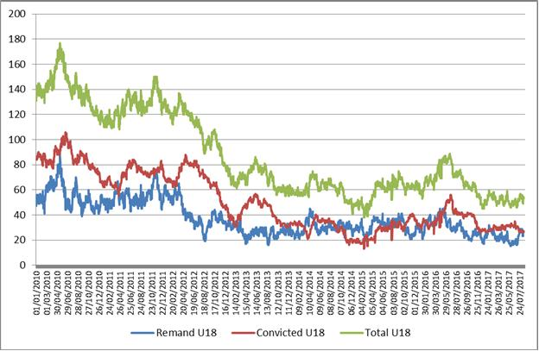

*Source: Scottish Prison Service August 2017*

**2.3 Offending by children and young people who receive a custodial sentence**

*Diversion was used several times to try to address Danny’s early offending.*

*Subsequently he was subject to several disposals through the CHS, a Community Payback Order (CPO) with a supervision requirement and a Restriction of Liberty order (RLO). He failed to comply with the CPO and breached the RLO.*

Although most children who are involved in offending usually commit offences at the less serious end of the scale, some children and young people cause harm to individuals and communities and a small number commit extremely serious crimes. This section considers the offences of children and young people who have been given custodial sentences.

**2.3.1 Offending by 16 and 17 year olds who receive a custodial sentence**

Ninety-five children aged 16 and 17 were sentenced to custody in 2015-16 (Scottish Government Criminal Proceedings database). Many of these children would previously have been in contact with the CHS and subject to earlier measures to seek to address their needs and offending behaviour (Scottish Prison Service). The **main** crime for which each individual was given a custodial sentence is shown in Table 2. For those individuals who were given more than one sentence at the same time the ‘main crime’ has been identified as the crime for which the longest sentence was given; those who were given more than one sentence at different times during the year appear more than once in the figures. The frequency of those crimes, which attracted more than five custodial sentences in 2015-16, are presented in Table 2; crimes which attracted between one and five sentences are also listed.

**Table 2: Main crime leading to a custodial sentence for 16 and 17 year olds in 2015-16**

|  |  |
| --- | --- |
| Crime | Number of sentences |
| Serious Assault | **18** |
| Common assault | **15** |
| Common assault of an emergency worker | **10** |
| Theft by housebreaking | **10** |
| Bail offences other than absconding or re-offending | **8** |
| Having in a public place an article with a blade or point | **6** |
| Attempted Murder | **\*** |
| Communicating indecently with young child (under 13) | **\*** |
| Culpable and reckless conduct (not with firearms) | **\*** |
| Dangerous driving offences | **\*** |
| Failing to appear for trial having been given court bail | **\*** |
| Fireraising excluding Muirburn | **\*** |
| General attempts to defeat/pervert the course ends of justice | **\*** |
| Obstructing constable in pursuance of lawful duty | **\*** |
| Reset | **\*** |
| Robbery and assault with intent to rob | **\*** |
| Sexual assault of young child (under 13) | **\*** |
| Supply, possession with intent to supply etc of drugs | **\*** |
| Theft by opening lockfast places (excl. motor vehicle) | **\*** |
| Theft by shoplifting | **\*** |
| Theft from a motor vehicle not elsewhere classified | **\*** |
| Theft not elsewhere classified (excl motor vehicle) | **\*** |
| Theft of motor vehicle & contents (including taking and driving away) | **\*** |
| Threatening or abusive behaviour | **\*** |
| Vandalism, reckless damage and malicious mischief | **\*** |
| Total | **106** |

* denotes five or fewer (in alphabetical order, not order of frequency)

*Note that this total represents 95 young people, some of whom were sentenced on more than one occasion during the year.*

The most common ‘main’ offences for this age group are crimes of violence and housebreaking. Table 2 oversimplifies the offending patterns of these children, however, since many of the individuals were convicted and sentenced for other crimes in addition to the main crime. Fifty-five of the 95 individuals sentenced to custody in 2015-16 were given one custodial sentence; a further 31 young people were given between two and four custodial sentences and nine received between five and nine custodial sentences during the year (sometimes with sentences being given for more than one crime at the same time and sometimes with trials at different times during the year). When **all** the crimes for which 16 and 17 year olds were given custodial sentences are taken together the pattern shown in Figure 6 emerges.

*Danny’s first custodial sentence (of three months) was when he was age 16 years 6 months and was for breach of bail. He served 45 days including two periods of remand.*

**Figure 6: Ten most frequent crimes for which 16 and 17 year olds were given a custodial sentence in 2015-16**

**:**

*\* not including absconding or reoffending. In addition there were 45 custodial sentences for other crimes which numbered fewer than five throughout the year.*

*Source: Criminal Proceedings Database, Scottish Government*

**2.3.2 Offences committed by 18 to 21 year olds receiving a custodial sentence**

As shown in Table 1, the rate of conviction of 41 per 1000 population of 18 to 20 year olds is higher than that for 16 and 17 year olds (15 per 1000 population), and has fallen less markedly than that for the younger age group. This is reflected in the numbers receiving custodial sentences. A total of 517 individual young people aged between 18 and 21 were sentenced to custody in 2015-16 (Scottish Government Criminal Proceedings database).

Of this number:

* 310 received one custodial sentence;
* 142 received two or three custodial sentences; and
* 65 received four or more custodial sentences

resulting in a total of 983 sentences.

When all the custodial sentences given to 18 to 20 year olds are considered, their offences follow a similar pattern to the under 18s, with the six most common crimes being as follows:

* bail offence (181);
* common assault (152);
* threatening/abusive behaviour (128);
* serious assault (82);
* common assault of emergency worker (56);
* theft by housebreaking (56).

The most common crime listed for both age ranges is a bail offence, although custodial sentences are rarely given for bail offences alone. Bail offences can include a range of different breaches, including not being at a particular place at a particular time, having contact with someone from whom the young person has been banned from associating or committing another offence. The high incidence of bail offences within the typical patterns of offending leading towards custody suggests a need to explore whether we could do more to better support children and young people to meet conditions placed upon them, and whether there could be alternatives to custody where bail conditions are breached. This echoes the recommendations of research on the criminalisation of looked after children by Moodie and Nolan (2016).

It will be important to keep the information on types of crime under review, recognising that custody should only be used for the most serious offences.

***Points for reflection:***

* *Are there any lessons to be drawn from the reductions in the numbers of 16 and 17 year olds being convicted and which might be translated to young people aged 18 to 20, whose prevalence of offending is higher and yet whose needs and circumstances may be similar to those of the younger age group?*
* *What more could be done to support young people to meet conditions placed upon them and reduce the number of bail offences?*
* *Given that three of the five main crimes were assault, is there more that could be done to address violent behaviour by children and young people?*

**2.4 Profile of the population of children and young people in custody**

We now consider the profile of the population of children and young people in custody by examining a typical snapshot.

**Figure 7: Population of children and young people in custody: snapshot April 2017**

|  |  |  |  |  |
| --- | --- | --- | --- | --- |
| **Age** | 16 and 17 | | 18 to 21 | |
|  | Young women | Young men | Young women | Young men |
| Number  (sentenced + remand) | 2 | 45 | 11 | 297 |
| Of which on remand | 2  (100%) | 16  (36%) | 6  (55%) | 82  (28%) |

*Source: Scottish Prison Service*

**2.4.1 Gender**

An obvious feature of the profile of children and young people in custody is the much lower number of girls and young women than boys and young men. Since mid-2010 there have been consistently fewer than six and frequently no girls under 18 in custody in Scotland. Between 2010 and 2016, there were generally between 22 and 34 young women under 21 in custody, representing between 2.4% and 5.4% of the total under 21 custodial population. During 2017, the numbers of young women under 21 in custody have dropped further and have recently been around 12.

**2.4.2 Age profile**

The numbers of young men in custody generally increase from age 16 to age 20 (Source: Scottish Prison Service).

Although there are relatively few 16 and 17-year old children in custody in comparison to older people, the ambition must be to reduce this number as far as is possible, ensuring that only those for whom custody is the best and only option are given such sentences. Similarly, it is important to consider how to minimise the numbers of those aged 18 to 21 in custody: many of these young people are developmentally younger than their chronological age and have the same vulnerabilities as the younger age group, but often have less access to the kind of support that is available to 16 and 17 year olds through the Whole System Approach. The need for continuing support for young adults is recognised through the additional support, which is available for care leavers under 26 (Scottish Government, 2016).

**2.4.3 Children and young people in custody on remand**

Children and young people on remand are those who are held in custody in secure care or in a Young Offenders Institution whilst awaiting trial or, having been convicted, awaiting sentencing. Remand is generally for an initial period of seven days and may be extended to 140 days in appropriate circumstances. Remand is used when bail is not considered appropriate. Children and young people on remand are housed within the YOI separately from sentenced young people, given that they should be treated as innocent unless and until found guilty. Young people on remand should be able to access the same services, support and education as convicted young people and efforts are made to enable this.

Figure 5 above shows in red the numbers of children under 18 who were on remand. The numbers who are on remand have not declined to the same extent as those who are serving sentences and it is notable that the number of children and young people who were on remand has on some occasions equalled or exceeded the number who had been sentenced. SPS population snapshots indicate that the proportion of young people in custody who are on remand is often highest for 16-year-olds.

*Danny experienced a total of five periods of remand totalling 80 days, both while untried and then while awaiting sentence following conviction.*

A young person who spends time in custody on remand will experience the same effects of separation and impact on relationships, employment and education as those who are sentenced to custody. When there is a high proportion of young people who are on remand within an establishment it can be particularly difficult to achieve high levels of participation in planning and activities, thereby diminishing the opportunities for learning and development. There are a number of reasons for this: they have not been convicted and so are not obliged to undertake any activity, they may be preoccupied with the process of their trials and/or they are likely to be uncertain about whether or how long they may be in custody.

Figures on the length of time spent by children and young people on remand have not been routinely gathered so, for example, it is not straightforwardto explore any patterns in the use of remand across the country. We will undertake more work to try to gain a picture of how children and young people move from remand in custody to sentencing in an attempt to gain more insight into young people’s routes through the system. Similarly, where children and young people are released directly from court having been on remand, comprehensive information is not available indicating whether they were found not guilty or whether they were sentenced to custody but that the sentence was back-dated to account for time served on remand.

***Points for reflection:***

* *What can we learn from the trends in children’s offending that might help to prevent future offending and enable the downward trend to continue?*
* *What more might be done to minimise the numbers of children and young people who are on remand?*

**2.4.4 Lengths of sentence**

As mentioned earlier, any time spent in custody is disruptive to a child or young person’s relationships and opportunities in the community, including education, training and employment opportunities, financial stability, often accommodation status, and inclusion in mainstream society. Time in custody can also have a negative impact on maturation, transformations in self-identity and on a child or young person’s ability to lead a happy, healthy and successful life. Moreover, each of these factors is also recognised as underpinning effective reintegration and supporting desistance, increasing the significance of such disruption (Youth Justice Board, 2005; McNeill, Farrall, Lightowler and Maruna, 2012).

The SPS young people’s strategy seeks ‘to use the time a young person spends in custody to enable them to prepare for a positive future’ (SPS Vision for Young People in Custody). Its implementation has included a broadening of the kinds of activity and services available to children and young people, upgraded facilities and enhanced staff training. The intentions of the strategy require sufficient time to get to know the young person and work with them to assess their strengths and needs, then plan and carry out a programme to enable them to build their skills, and finally to prepare them and those who will support them in the community for their release. Lengths of sentence have a bearing on how much can be achieved during a period of custody. We consider below what we know about sentence lengths, from two sources.

First, the Scottish Government Criminal Proceedings Database records all the individual custodial sentences given to children and young people for the crimes for which they have been convicted. The distribution of sentence lengths is shown below (Fig 8a). Note however that, as discussed earlier, individual children and young people are frequently given more than one custodial sentence.

**Figure 9(a): Length of sentence – all custodial sentences given to 16 and 17 year olds in 2015-16**

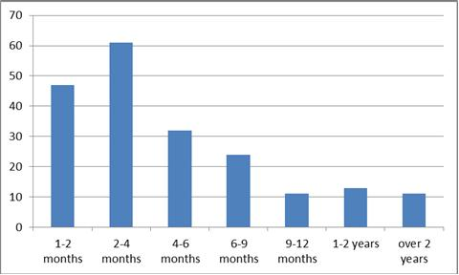

*Danny’s current custodial sentences (of 1 year 9 months) began one month after he was released from his initial sentence. They are for:*

*Assaulting or impeding Police (x 3),*

*Assault (x 4), Threatening and abusive behaviour (x 4), Breach of bail and Theft by Shoplifting*

*All of these sentences are concurrent.*

*Source: Criminal Proceedings Database, Scottish Government*

**Figure 9(b): Length of sentence – all custodial sentences given to 18 to 21 year olds in 2015-16**

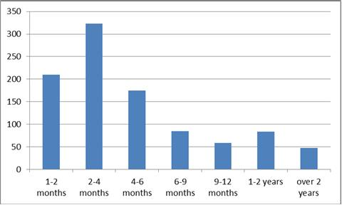  
*Source: Criminal Proceedings Database, Scottish Government*

These figures indicate that in 2015-16, the most frequent length of sentence for both 16 and 17 year olds and 18 to 20 year olds was two to four months. Some of these shorter sentences are, however, consecutive to, or concurrent with, sentences for other offences. The *Criminal Justice and Licensing (Scotland) Act 2010* introduced a presumption against short-term prison sentences of less than three months. The Scottish Government’s Programme for Government, which was announced on 5 September 2017, pledged to extend the presumption against short sentences to 12 months. The Scottish Sentencing Council is also developing a sentencing guideline focussing on sentencing of young people.

A second source of information about the distribution of sentence lengths is SPS prison records. These can provide snapshots of the distribution of sentence lengths for the population in custody on any one day. These figures represent the total length of the sentences (not time spent in custody) for each individual, bearing in mind that that most young people receive custodial sentences for more than one offence, and that the individual sentences given may be concurrent, consecutive or a mixture of both.

**Figure 10(a) Length of sentences for 16 and 17 year olds in custody April 2017** 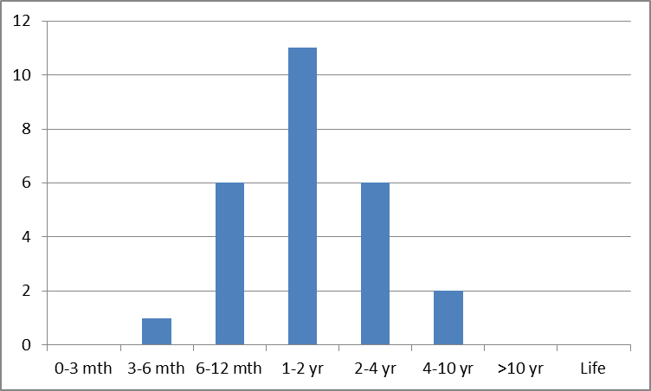

*Source SPS*

**Figure 10(b) Lengths of sentences for all under 21 year olds in custody April 2017**

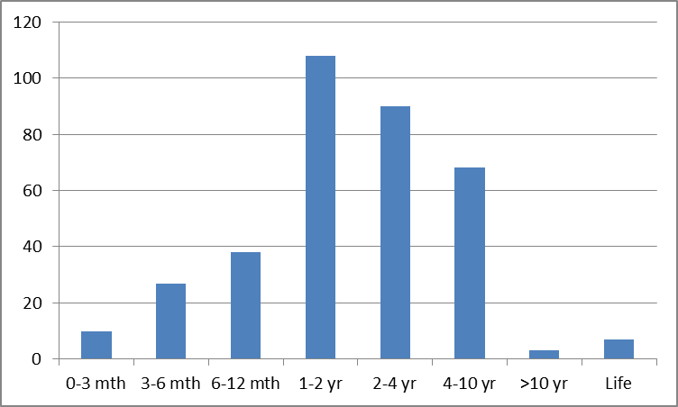

*Source: SPS*

These figures indicate that the most common total sentence length is between one and two years. However, these individual snapshots underestimate the numbers of shorter sentences served in any year (because a snapshot will not able to ‘see’ all the individuals who serve, say, one month in the year, although it will include all those who serve the full year or more).

Because of these complexities we do not yet have a comprehensive picture of the distribution of sentence lengths for children and young people. What is clear is that some young people are currently serving relatively short sentences. Such sentences inevitably mean more limited opportunities to develop relationships during custody, build skills and find reasons to make changes (‘hooks for change’).

***Points for reflection:***

* *How far is the presumption against short sentences currently a reality?*
* *Given that we are already striving towards a move away from short sentences for 16 and 17 year olds, what impact will extending the presumption against short sentences to 12 months or less have?*
* *Are there risks of ‘up-tariffing’ to longer sentences if shorter sentences are avoided?*
* *What further alternatives might there be to short custodial sentences? How can we encourage the use of such alternatives and build understanding of, and confidence in, them?*
* *Are there other ways in which the adverse impacts of periods of remand and shorter sentences on factors linked with desistance can be minimised?*
* *Could benefit be gained from a greater understanding of the time young people are spending in custody both on remand and whilst serving sentences?*

*When Danny first arrived in Polmont he found it difficult to speak to the other young people. He was involved in two fights and disengaged from assessment processes which were designed to help him address his offending behaviour. Recently he has taken part in some sport and youth work activities. He is beginning to build a relationship with his Personal Officer, starting to speak to her about his early life and the things he is interested in.*

**3. What happens after custody?**

**3.1 Liberation and throughcare**

Liberation after even a short period in custody is known to be a traumatic experience for a child or young person. Even though they may be looking forward to their liberation they may be naïve about the potential enormity of this change:

“…Children’s related experiences [in the weeks post-release] are consistent with symptoms of adjustment disorders which carry increased risks of long-term psychiatric illnesses and suicide” (Bateman and Hazel, 2015, p.3). “It is therefore unsurprising that the shock of leaving custody may undermine an individual’s commitment to ceasing offending and the prospect of desistance, with the period immediately following release being associated with increased risk of breach, reoffending and other negative outcomes.” (Bateman and Hazel, 2015).

It is imperative that all children and young people in custody and their families are provided with good quality throughcare support - that is, a range of supports provided by social work and other services, both statutory and third sector, from within and outside the criminal justice system, from the point of sentence or remand, during their period of detention and subsequent return and reintegration to the community (Malloch, 2013a; Scottish Government, 2011b). This is fundamental if young people are to be adequately supported during their period in custody, through the transition of returning to their community and subsequently reintegrating, as well as to reduce the likelihood of reoffending and ultimately to support desistance (Malloch, 2013; [Griffiths, Daudurand and Murdoch, 2007](https://www.publicsafety.gc.ca/cnt/rsrcs/pblctns/scl-rntgrtn/scl-rntgrtn-eng.pdf)).

*Danny is already concerned about where he will live after his sentence. He feels that he will not be able to stay away from alcohol if he lives with his dad. He also realises that he needs to find better ways of spending his time if he is to stop offending. He hopes to gain skills in joinery while he is in custody to help him to get a job.*

Cesaroni’s study of young people in HMYOI Polmont confirmed how important it is to young people leaving custody that they have support when they return to the community: within the sample of 103, 73% indicated that it was very important for them to receive support for getting a job, 66% to find a proper home or housing and 61% to build relationships with their family. This highlights the importance of throughcare support and also the specific areas of concern for young people leaving custody. Because of their stage of maturity and circumstances the transition to the community can be especially challenging. Some of the young people will not have lived independently, were homeless when they entered custody, or would be on their own for the first time when they left custody. Many of the young people have never had a job. Making the successful transition through these important lifetime transitions (work and home) is important to their eventual lifetime success as adults (Cesaroni, 2017).

A number of principles of effective throughcare and examples of effective reintegration practice are evident (see CYCJ, 2016), and recent improvements such as the introduction of SPS Throughcare Support Officers are having a beneficial impact. Providing such support is challenging for various reasons. These include the complexity of needs of many of the young people leaving custody and the often chaotic context within which they live their lives; their developmental stage and needs; the difficulties in measuring effectiveness; wider systems issues outwith the criminal justice system; and complexities of partnership working (Malloch, 2013; Griffiths et al., 2007; Bateman and Hazel, 2015). Young people may need to find suitable accommodation and a plan for how they will spend their time in work, learning and other pro-social activity. They may need support to access medical or mental health services and the benefits system.

There are encouraging examples of successes as a result of strong partnership working and effective support, but the necessary supports are not consistently in place across the country and, as we have seen, some periods in custody are short, limiting the scope to have comprehensive support in place at the point of liberation.

**3.2 Reasons for Liberation**

High-quality throughcare support is challenging where a child or young person’s date of liberation is known and there is sufficient time to plan for relevant aspects of support. But liberation is not always a planned move at the completion of a sentence. Table 3 lists the reasons for liberation of 58 16 and 17 year olds who were liberated from HMYOI Polmont (not under statutory supervision) in 2015.

**Table 3: Means of liberation from HMYOI Polmont, 2015**

|  |  |  |  |  |  |
| --- | --- | --- | --- | --- | --- |
| **Liberated to community** | | | | | |
| *Sentence expired* | | *20* | | *34%* | |
| *Released from court* | | *14* | | *24%* | |
| *From Procurator Fiscal* | | *3* | | *5%* | |
| **Liberated on bail or interim liberation** | | | | | |
| *Bail* | | *16* | | *28%* | |
| *Interim liberation* | | *1* | | *2%* | |
| **Liberated elsewhere (non-community)** | | | | | |
| *Immigration Authority, Mental Health Service/ Hospital, Secure Unit, Local Authority, Deported* | *4* | | *7%* | |
| **Total** | | **58** | | **100%** | |

The data in this table shows that only a third of 16 and 17 year olds who were not under statutory supervision and were liberated from HMYOI Polmont in 2015 were liberated because their sentence had expired. In these cases, depending on sentence length, there was the possibility of having detailed plans in place for their return to the community. The remaining two-thirds were liberated for other reasons: release on bail or interim liberation; transition to a different placement; and release to the community directly from court or through the Procurator Fiscal. In these instances, systematic support for the children’s transition from custody might not be in place. Throughcare is an extremely challenging area of practice but if we are to improve outcomes for these children and young people, and ultimately for the benefit of society, we need to seek to get it right every time a child or young person is released from custody.

***Points for reflection:***

* *What barriers do children and young people face that can prevent successful transitions to the community and what more could we do to overcome these?*
* *Some children spend time on remand and are released from court or to a period of bail. How can we ensure that they receive the support they may need to enable them to return successfully to the community?*

**3.3 Reconviction rates**

Reconviction rates for children and young people who were reconvicted within one year after having been discharged from custody are shown in Table 4.

It should be noted that reconviction rates are rather blunt measures and should be treated with caution. For a number of reasons they should not be viewed as a measure of the effectiveness of a youth justice system: the new conviction may in fact be for an offence which was committed before the young person’s time in custody (it is not known to what extent the reconvictions are for offences which were committed after release from custody); the path to desistance is not straightforward and may include some further offending; and the reconviction rate does not take account of the gravity of the additional offence/s.

**Table 4: Reconviction rates after one year for different cohorts of children and young people following discharge from custody: all disposals (custodial and non-custodial)**

|  |  |  |  |  |  |
| --- | --- | --- | --- | --- | --- |
| **Reconviction rates for 16 and 17 year olds discharged from custody: all disposals (custodial and non-custodial)** | | | | | |
|  | All (n = 146) | Number of previous convictions | | | |
| None (n = 55) | 1 or 2 (n =44) | 3 to 10 (n = 44) | Over 10 (n = 3) |
| 2012-13 cohort (male and female) | 52.7% | 36% | 52% | 70% | - |
|  | All (n = 132) | Number of previous convictions | | | |
| None (n = 47 ) | 1 or 2 (n = 42) | 3 to 10 (n = 41) | Over 10 (n = 2 ) |
| 2013-14 cohort (male and female) | 47.0% | 32% | 50% | 61% | - |
|  | All (n = 75) | Number of previous convictions | | | |
| None (n = 25 ) | 1 or 2 (n = 25) | 3 to 10 (n = 25) | Over 10 (n = 0 ) |
| 2014-15 cohort (male and female) | 58.7% | 44% | 60% | 72% | - |

*Source: Scottish Government Analytical Services*

|  |  |  |  |  |  |
| --- | --- | --- | --- | --- | --- |
| **Reconviction rates for 16 to 21 year olds discharged from custody: all disposals (custodial and non-custodial)** | | | | | |
|  | All (n =819) | Number of previous convictions | | | |
| None (n = 143) | 1 or 2 (n = 174) | 3 to 10 (n = 380) | Over 10 (n = 122) |
| 2012-13 cohort (male ) | 47.3% | 27% | 36% | 52% | 72% |
|  | All (n = 50) | Number of previous convictions | | | |
| None (n = 13) | 1 or 2 (n = 14) | 3 to 10 (n = 12) | Over 10 (n = 11) |
| 2012-13 cohort (female) | 44.0% |  |  |  |  |
|  | All (n = 664) | Number of previous convictions | | | |
| None (n = 110) | 1 or 2 (n = 145) | 3 to 10 (n = 321) | Over 10 (n = 88) |
| 2013-14 cohort (male ) | 47.0% | 23% | 33% | 55% | 70% |
|  | All (n = 35) | Number of previous convictions | | | |
| None (n = 7) | 1 or 2 (n = 11) | 3 to 10 (n = 12) | Over 10 (n = 5) |
|  |  |  |  |  |  |
| 2013-14 cohort (female) | 40% |  |  |  |  |
|  | All (n = 527) | Number of previous convictions | | | |
| None (n = 82) | 1 or 2 (n = 106) | 3 to 10 (n = 283) | Over 10 (n = 56) |
| 2014-15 cohort (male ) | 49.0% | 22% | 41% | 56% | 68% |
|  | All (n = 30) | Number of previous convictions | | | |
| None (n = 5) | 1 or 2 (n = 5) | 3 to 10 (n = 18) | Over 10 (n = 2) |
| 2014-15 cohort (female) | 60% |  |  |  |  |

*Source: Scottish Government Analytical Services*

*Note: the numbers of 16 and 17 year olds and the number of young women are small, therefore particular caution should be applied in interpreting those percentages or identifying any trends.*

Table 4 shows that reconviction rates for young men consistently rise with the number of previous convictions, and rates for 16 and 17 year old young men are higher than for those for the entire age range from 16 to 21.

Because the decreasing population of young people in custody, especially of 16 and 17 year olds, includes a higher proportion of individuals with particularly complex needs who have committed violent offences, it is possible that reconviction rates might rise. Figures to date do not reflect this, but it will be informative to continue to review these.

**3.3.1 Reconviction resulting in a further custodial sentence**

The figures in table 4 include all types of sentence, non-custodial as well as custodial. The figures for reconvictions leading to a further *custodial* sentence for the 2000-01 and 2014-15 cohorts of young men are shown in Table 5.

**Table 5: Reconviction rates after one year for different cohorts of young men following discharge from custody: custodial disposals only**

|  |  |  |  |
| --- | --- | --- | --- |
| 2000-01 cohort | 40% (n=1022) | 2014-15 cohort | 29% (n=527) |

*Source: Scottish Government Analytical Services*

For the cohort of young people under 21 who were released from custody in 2014-15, both the overall numbers receiving a further custodial sentence and the proportion reconvicted to custody have fallen since 2000-01. Although the figures need to be treated with caution they do not seem to support the archetypal ‘revolving door’ theory.

***Point for reflection:***

* *What more might be done to reduce offending by young people with large numbers of previous convictions, who are at particularly high risk of reoffending and reconviction?*

**Conclusion**

This paper has sought to bring together evidence and data from a range of sources to support reflection and inform change and improvement.

Given what we have learned about the needs and circumstances of children and young people who come into custody, what do we need to do to preserve and sustain the best of current practice?

How can we develop practice and policy further to promote better outcomes for children and young people in the justice system and, by doing so, reduce harm to communities and potential victims?

**References**

Bateman, T. (2015) NAYJ briefing The state of youth justice 2015: an overview of trends and developments. <http://thenayj.org.uk/wp-content/uploads/2015/10/State-of-Youth-Justice-Oct15.pdf>

Bateman, T. and Hazel, N. (2015).[*Custody to community: how young people cope with release: research report*](http://www.beyondyouthcustody.net/resources/publications/custody-community-young-people-cope-release-research-report/)*.* London: Beyond Youth Custody.

British Psychological Society (2015) Position Paper Children and Young People with Neuro-Disabilities in the Criminal Justice System, <http://www.bps.org.uk/system/files/Public%20files/Policy/pp04_brain_and_justice_dec2015-_final.pdf> Leicester, UK.

Broderick, R. and Carnie, J. (2016) Young People in Custody 2015, <http://www.sps.gov.uk/Corporate/Publications/Publication-3908.aspx>

Cesaroni, C. (2017) Forthcoming

Crimmins, S., Cleary, S., Brownstein, B. & Warley, R. (2000). Trauma, violence and drugs amongst juvenile offenders. Journal of Psychoactive Drugs, 32 (1): 43 - 51.

CYCJ (2014) Young Men in Custody, <http://www.cycj.org.uk/resource/young-men-in-custody-a-report-on-the-pathways-into-and-out-of-prison-of-young-men-aged-16-and-17/>

CYCJ (2016) A Guide to Youth Justice in Scotland: Section 6: Reintegration and Transitions, http://www.cycj.org.uk/resource/section-6-reintegration-and-transitions/

Dyer, F. and Nolan, D. Forthcoming

Grella C.E., Stein J.A., Greenwell L. Associations among childhood trauma, adolescent problem behaviors, and adverse adult outcomes in substance-abusing women offenders. Psychology of Addictive Behaviors. 2005;19:43-53

Griffiths, C., Dandurand, Y. and Murdoch, D. (2007). [*The Social Reintegration of Offenders and Crime Prevention*](https://www.publicsafety.gc.ca/cnt/rsrcs/pblctns/scl-rntgrtn/scl-rntgrtn-eng.pdf). Canada: International Centre for Criminal Law Reform and Criminal Justice Policy.

Henderson, G. et al. (2016) Backgrounds and outcomes for children aged 8 to 11 years old who have been referred to the Children’s Reporter for offending, <http://www.scra.gov.uk/wp-content/uploads/2016/03/Backgrounds-and-outcomes-for-children-aged-8-11-years-old-who-have-been-referred-for-offending.pdf>

Malloch, M. (2013a). [*The Elements of Effective Through-care Part 2: Scottish Review*](http://www.sccjr.ac.uk/publications/the-elements-of-effective-through-care-part-2-scottish-review/). Glasgow: SCCJR.

McAra, L. and McVie, S. (2010) Youth crime and Justice: Key Messages from the Edinburgh Study of Youth Transitions and Crime, [www.research.ed.ac.uk/portal/files/8195355/Youth_crime_and_justice_Key_messages_from_the_Edinburgh_Study_of_Youth_Transitions_and_Crime_Criminology_and_Criminal_Justice.pdf](http://www.research.ed.ac.uk/portal/files/8195355/Youth_crime_and_justice_Key_messages_from_the_Edinburgh_Study_of_Youth_Transitions_and_Crime_Criminology_and_Criminal_Justice.pdf)

Moore, E., Gaskin, C. and Indig, D (2013) [*Childhood maltreatment and post-traumatic stress disorder among incarcerated young offenders*](http://www.sciencedirect.com/science/article/pii/S014521341300207X) Child abuse and neglect vol. 37 pp 861-870, Elsevier

Ryan, J. P., and Testa, M. F. (2005). Child maltreatment and juvenile delinquency: Investigating the role of placement and placement instability. Children and Youth Services Review, 27(3), 227-249.

Savage, R.C. (2012) The developing brain after TBI: predicting long term deficits and services for children, adolescents and young adults, <http://www.internationalbrain.org/articles/the-developing-brain-after-tbi/>

Scottish Government. (2011). [*Reintegration and Transitions - Guidance for Local Authorities, Community Planning Partnerships and Service Providers*](http://www.scotland.gov.uk/Publications/2011/09/28085123/19)*.* Edinburgh: Scottish Government.

Scottish Government (2013) Scottish Policing Performance Framework, 2012-13. Edinburgh: Scottish Government. Retrieved from [www.scotland.gov.uk/Publications/2013/11/6914](http://www.scotland.gov.uk/Publications/2013/11/6914).

Scottish Government. (2015). [*Summary statistics for schools in Scotland*](http://www.gov.scot/Resource/0049/00490590.pdf). Edinburgh: Scottish Government.

Scottish Government (2016) [*Children’s Social Work Statistics Scotland, 2014-15*](http://www.gov.scot/Resource/0049/00497773.pdf). Edinburgh: Scottish Government. Social Exclusion Unit (2002) *Reducing re-offending by ex-prisoners* London: Home Office.

United Nations (1989) <https://downloads.unicef.org.uk/wp-content/uploads/2010/05/UNCRC_united_nations_convention_on_the_rights_of_the_child.pdf?_ga=2.110213889.509515872.1495023093-155645293.1495022993>

Vaswani, N. (2014) The Ripples of Death: Exploring the Bereavement Experiences and Mental Health of Young Men in Custody, <http://onlinelibrary.wiley.com/doi/10.1111/hojo.12064/full>

Wilson, H., [Berent, E](https://www.ncbi.nlm.nih.gov/pubmed/?term=Berent%20E%5BAuthor%5D&cauthor=true&cauthor_uid=24273468)., [Donenberg, G.R](https://www.ncbi.nlm.nih.gov/pubmed/?term=Donenberg%20GR%5BAuthor%5D&cauthor=true&cauthor_uid=24273468)., [Emerson, E.M](https://www.ncbi.nlm.nih.gov/pubmed/?term=Emerson%20EM%5BAuthor%5D&cauthor=true&cauthor_uid=24273468)., [Rodriguez, E.M](https://www.ncbi.nlm.nih.gov/pubmed/?term=Rodriguez%20EM%5BAuthor%5D&cauthor=true&cauthor_uid=24273468). and Sanderesa, A. (2013) Trauma History and PTSD Symptoms in Juvenile Offenders on Probation, Victims and Offenders 8: 465 - 477 doi:10.1080/15564886.2013.835296.

Youth Justice Board. (2005). [*Youth Resettlement A framework for action*](http://yjbpublications.justice.gov.uk/Resources/Downloads/Youth%20Resettlement%20Framework%20for%20Action.pdf). England: Youth Justice Board.

Youth Justice Improvement Board (2016) [*Educational exclusion and inclusion - Common themes from the Improving Life Chances Group.* Glasgow: CYCJ](https://www.google.co.uk/url?sa=t&rct=j&q=&esrc=s&source=web&cd=2&ved=0ahUKEwiE55PZ8tjSAhWBJ8AKHRbCDjQQFggpMAE&url=http%3A%2F%2Fwww.cycj.org.uk%2Fresource%2Feducational-exclusion-and-inclusion-common-themes-from-the-improving-life-chances-group%2F&usg=AFQjCNHmMs5fP_RlEpxq2AfHAukTG-fnVw)