Adverse Childhood Experiences in children at high risk of harm to others. A gendered perspective.

Nina Vaswani

January 2018

Abstract
The body of evidence linking a range of Adverse Childhood Experiences (ACEs) to health-harming behaviours and poorer health outcomes is becoming increasingly better understood. Although these experiences are surprisingly common in the general population, certain vulnerable groups, such as people involved in offending, are known to have experienced higher levels of adversity than others. This paper documents the prevalence of Adverse Childhood Experiences in a sample of 130 young people aged under 18 who present high levels of risk in relation to serious violent, sexual or extremist behaviours. The paper also considers the impact of childhood bereavement which, although known to be a common feature in the lives of young people involved in offending, is rarely documented in Adverse Childhood Experience studies. The paper confirms elevated levels of adversity in the backgrounds of these vulnerable young people who pose a high risk of harm, but also presents potential evidence of gender effects and begins to reflect on how gender might interact with how young people, and the systems and professionals around them, respond to adversity in childhood. The paper suggests that this gendered response to Adverse Childhood Experiences may underlie the excess criminality seen among males, and that future studies should test this hypothesis directly.

Contents
Introduction 4
Adverse Childhood Experiences and Offending 4
Limitations in existing research: geography, bereavement and gender 5
Geography 5
Bereavement 6
Gender 6
Interventions for Vulnerable Youth (IVY) 7
The Research Questions 7
Method 7
Ethics 7
Procedure 7
Sample 8
Analysis 8
Limitations 8
Results 9
Exposure to Adverse Childhood Experiences 9
Relationship to outcomes 12
Discussion 13
References 16
Appendix 1 18

Introduction
The long term relationship between Adverse Childhood Experiences (ACEs), health-harming behaviours, poor health outcomes and, ultimately, early mortality was first documented by Felitti et al. (1998). This large-scale study, partnered with the Center for Disease Control and involving more than 8,000 adults attending a Health Appraisal Clinic in San Diego for a routine medical examination, asked participants to document their childhood experience of seven categories of adverse experiences. Three of these categories related to abuse (sexual; physical and emotional); and the remaining four were indicators of household dysfunction (familial substance abuse; familial mental illness, domestic violence in the home and the incarceration of a household member). A composite Adverse Childhood Experience ‘score’ was calculated (a simple summation of the presence of each Adverse Childhood Experience, regardless of the intensity or duration of the experience). The prevalence of Adverse Childhood Experiences ranged from 3.4% (incarceration of a household member) to 25.6% (substance abuse within the household). Around half of participants (50.5%) had experienced at least one Adverse Childhood Experience, and 6.2% had experienced four or more. More strikingly, the authors found a strong dose-response relationship between the number of Adverse Childhood Experiences experienced and the presence of health risk factors and diseases implicated in the leading causes of death in adults. For example, respondents with exposure to four or more Adverse Childhood Experiences were more than twice as likely to be a smoker than respondents with no exposure to the measured Adverse Childhood Experiences; the odds of experiencing depression in the past year were almost fivefold; alcohol addiction sevenfold; and suicide attempts were 12 times more likely. In relation to non-communicable diseases, the odds of ischemic heart disease, cancer and stroke were roughly twice as likely in those participants exposed to four or more Adverse Childhood Experiences, and chronic lung disease occurred four times more frequently.
In the intervening years researchers have replicated the findings of the original Adverse Childhood Experience study with remarkable consistency, and exposure to Adverse Childhood Experiences in childhood has been found to have a strong and graded association with a range of health behaviours and outcomes, including: early onset of alcohol use (Dube et al., 2006); binge-drinking (Bellis et al., 2015; Bellis, Hughes, Leckenby, Perkins, & Lowey, 2014; Bellis, Lowey, Leckenby, Hughes, & Harrison, 2014); alcohol addiction (Anda et al., 2002); illicit drug use (Dube et al., 2003); depression (Anda et al., 2002; Chapman et al., 2004; Fang, Chuang, & Lee, 2016; Schilling, Aseltine, & Gore, 2007); low life satisfaction (Bellis, Lowey, et al., 2014); unintended teenage pregnancy (Bellis et al., 2015; Bellis, Hughes, et al., 2014; Hillis et al., 2004); HIV risk behaviours (Fang et al., 2016), as well as a range of non-communicable diseases (Brown et al., 2010; Dong et al., 2004; Dong, Dube, Felitti, Giles, & Anda, 2003) and premature death (Brown et al., 2009).
Adverse Childhood Experiences and Offending
General population studies of Adverse Childhood Experiences have also observed a relationship between exposure to Adverse Childhood Experiences and future violence, whether as a victim, a perpetrator, or often both. A nationally representative study of almost 4,000 participants in England found that respondents with four or more Adverse Childhood Experiences were seven times more likely to have been a victim of violence in the past year, and were eight times more likely to have committed a violent act than those with no Adverse Childhood Experiences. In Wales these figures were more pronounced, as those who had experienced four or more Adverse Childhood Experiences were 14 times more likely to have been a victim of violence in the past year, and 15 times more likely to have been the perpetrator of a violent incident (Bellis et al., 2015).
Studies that have retrospectively explored the background experiences of people involved in offending document disproportionately high levels of childhood adversity. In a study of 151 adult male offenders referred for psychological treatment for crimes of nonsexual child abuse; domestic violence; sexual offending and stalking, Reavis, Looman, Franco, and Rojas (2013) found that the mean number of Adverse Childhood Experiences experienced was 3.7, and that four times as many participants reported experiencing four or more Adverse Childhood Experiences than males in a normative sample. Similarly, a study of almost 700 adult male sex offenders (Levenson, Willis, & Prescott, 2016) found that the prevalence of Adverse Childhood Experiences was significantly higher than in the general population, with the odds of emotional abuse 13 times higher and parental separation and emotional neglect occurring four times more frequently than in the general sample.
Young people involved in offending are also found to have a higher rate of exposure to Adverse Childhood Experiences than the general population. Analysis of pre-existing risk assessments for around 64,000 young offenders in Florida (Baglivio et al., 2014) found that this group of young people were 13 times less likely to have had no exposure to any of the Adverse Childhood Experience categories than in the original Adverse Childhood Experience study, and were four times more likely to report four or more Adverse Childhood Experiences. Furthermore, the overall Adverse Childhood Experience ‘score’ was related to an increased level of risk of reoffending predicted by the risk assessment (rather than actual behaviour). A study of almost 12,000 young offenders (Fox, Perez, Cass, Baglivio, & Epps, 2015) found that, on average, exposure to each additional Adverse Childhood Experience increased the risk of becoming a serious, violent or chronic young offender by 35%, although some Adverse Childhood Experiences were found to have more impact on future behaviours (for example, physical abuse, or having an incarcerated family member).
Limitations in existing research: geography, bereavement and gender
That Adverse Childhood Experiences are common, interrelated and have a long-term impact on health and well-being is now well documented. The language of Adverse Childhood Experiences is filtering into common parlance, with the public able to complete an Adverse Childhood Experience questionnaire and calculate their own Adverse Childhood Experience score online. Adverse Childhood Experiences are even the subject of an award-winning film Resilience, with film-makers James Redford and Karen Pritzker inspired by the original study (Redford, 2016). This does not mean that the need for research into these experiences is no longer needed. There is broad consensus that addressing the impact of Adverse Childhood Experiences needs to be three-pronged and focus on preventing exposure to Adverse Childhood Experiences; increasing the resilience of those young people who have been exposed to adversity and reducing the risk to long-term health from health-harming behaviours (Bellis, Hughes, et al., 2014; Couper & Mackie, 2016; Felitti et al., 1998). However, to achieve this successfully more needs to be understood about how Adverse Childhood Experiences affect specific populations (and individuals within those populations), about what individual, environmental and societal factors increase or decrease resilience to Adverse Childhood Experiences (as experiencing adversity need not inevitably mean a life sentence) and the impact of other types of adversity not included in standardised Adverse Childhood Experience studies also needs to be considered.
Geography
While Adverse Childhood Experience studies have been conducted around the world, there have been no published research studies that have comprehensively focused on data from Scottish citizens. In Scotland there is growing interest among practitioners and policymakers into the prevalence and impact of Adverse Childhood Experiences (Couper & Mackie, 2016). Historically, Scotland has suffered from excess mortality, and higher prevalence of some Adverse Childhood Experiences compared to similar countries, and this association, although not gone unnoticed (Smith, Williamson, Walsh, & McCartney, 2016), has remained unexplored.
Bereavement
Bereavement is a common childhood experience, with around 3.5% to 5% of young people in the United Kingdom bereaved of a parent by age 16 (Fauth, Thompson, & Penny, 2009; Parsons, 2011). Some studies suggest that around three-quarters of young people experience bereavement in their wider family or social network by age 16 (Harrison & Harrington, 2001). Despite this, there is insufficient longitudinal evidence about the lasting impact of child bereavement, especially in relation to outcomes beyond psychological and emotional well-being (Akerman & Statham, 2014). However, retrospective studies of young people involved in offending have reported higher rates of parental, multiple and traumatic bereavements than in the general adolescent population (Finlay & Jones, 2000; Vaswani, 2008; Vaswani, 2014). Bereavement is therefore perhaps a potential omission from previous Adverse Childhood Experience studies, few of which include it as an Adverse Childhood Experience, and is especially pertinent to populations with higher than average mortality rates.
Gender
Gender differences in exposure to Adverse Childhood Experiences are commonly reported in the results sections of studies, but are rarely discussed as a significant theme. Population level studies tend to report slightly higher overall exposure to adversity among females, although exposure to each individual Adverse Childhood Experience does vary between genders and across studies. The original Adverse Childhood Experience study found that females were more likely to have experienced multiple Adverse Childhood Experiences although the significance, or otherwise, of this difference was not reported. For example, 8.5% of females experienced four or more Adverse Childhood Experiences, compared to 3.9% of males (Felitti et al., 1998). In the national household survey in England, females were significantly more likely to have been exposed to verbal abuse; sexual abuse; household mental illness and alcohol abuse within the household, and to have experienced higher Adverse Childhood Experience counts than males; but there were no gender differences in relation to exposure to the other Adverse Childhood Experiences (Bellis, Hughes, et al., 2014). Conversely, the Welsh population study (Bellis et al., 2015) found that males were significantly more likely than females to have experienced verbal and physical abuse, witnessed domestic violence, been affected by the imprisonment of a household member and to have been exposed to four or more Adverse Childhood Experiences.
Thus overall any gender differences in Adverse Childhood Experience exposure tend to be small and inconsistent, with the exception of sexual abuse which is invariably higher among females. While gender differences in exposure to adversity that involves some form of direct abuse towards children could potentially be understood in terms of societal, cultural or other underlying attitudes or actions, it is difficult to comprehend how adversity relating to household dysfunction might disproportionately affect one gender over the other. It cannot, therefore, be ruled out that underreporting occurs to some extent in the disclosure of all Adverse Childhood Experiences, especially among males. Adult retrospective recall of childhood events is assessed to be a sufficiently valid method for Adverse Childhood Experience studies, albeit one that is affected by underreporting (rather than false positives) (Felitti et al., 1998; Hardt & Rutter, 2004) and an element of bias (Hardt & Rutter, 2004). However, males are even less likely to disclose child abuse due to societal and cultural norms about masculinity, sexuality and vulnerability (Holmes & Slap, 1999; Levenson et al., 2016).

Interventions for Vulnerable Youth (IVY)
The Interventions for Vulnerable Youth (IVY) Project was established in 2013 in order to promote best practice in forensic mental health risk assessment and management for young people in Scotland who present a serious risk of harm to others. The IVY project stemmed from growing awareness that a significant proportion of young people with severe conduct and offending behaviour problems did not have access to services capable of meeting their complex needs. IVY provides a specialist psychological and social work service which reflects a multi-disciplinary tiered approach to risk assessment, formulation and management for young people aged 12 to 18 years who present with complex psychological needs and high-risk behaviour such as risk of violence, harmful sexual behaviour or extremism. The three tiers of IVY comprise distinct but related levels of assessment and formulation from Level 1 (a consultation and risk formation clinic); Level 2 (specialist psychological assessment) and Level 3 (treatment).
The Research Questions
This paper aims to begin to address some of the gaps in the research literature by considering the prevalence of Adverse Childhood Experiences in this population of young people who are presenting with complex behaviours and poor outcomes at an early stage in life. While only a population level study of Scotland could fully test relationship between Adverse Childhood Experiences and outcomes satisfactorily, this paper provides the first comprehensive and published evidence of Adverse Childhood Experiences in a Scottish population, albeit in a specific and unusual sample. In addition, the paper will begin to consider the relevance of factors such as bereavement and gender within this population. Specifically, the research questions were:
- What is the prevalence of Adverse Childhood Experiences in the IVY sample?
- What is the prevalence of bereavement in the IVY sample?
- Are there any differences between males and females in the IVY sample?
- What is the relationship between Adverse Childhood Experiences and key health and social outcomes in the IVY sample?
Method
Ethics
The study was given ethical approval by the University of Strathclyde’s Ethics Committee based in the School of Social Work and Social Policy. This scrutiny focuses on the well-being of participants and the security of data collected during the duration of the study.
Procedure
Historical and current risks, concerns and experiences are shared with IVY by multi-agency professionals working with the young person in a referral form, and elaborated on verbally in a multi-disciplinary case consultation clinic. This information is used to develop an individualised risk formulation, often informed by the completion of a SAVRY risk assessment tool (Borum, Bartel, & Forth, 2002) or other relevant assessment. This formulation is fed back to referrers in the form of a Risk Assessment Report (RAR). The research constituted secondary analysis of referral information and the Risk Assessment Reports (RARs) documenting the assessment and formulation clinics at Level 1. Consent was obtained from referrers at the point of referral to use the information provided for both risk formulation and research purposes.
A casefile reading tool was developed to document the presence of 10 Adverse Childhood Experiences including three categories of abuse (physical, emotional and sexual); two categories of neglect (physical and emotional) and five categories of household dysfunction (family mental illness, parental separation; family substance abuse; domestic violence and family imprisonment). In addition, the presence of bereavement was also documented. Bereavement was recorded as ‘parental’ bereavement when a biological or adoptive parent had died (regardless of the nature of that relationship), and was recorded as ‘other significant bereavement’ based on the nature of the relationship or the documented impact of the bereavement, rather than necessarily being defined by the young person as important. Examples of other significant bereavements typically included: the death of a grandparent (many of whom had been a main or regular caregiver for substantial periods of the young person’s life), death of a sibling and death of a friend by suicide. Both categories of bereavement were combined for the purposes of analysis. A range of key health and social outcomes for the young person were also identified from casefiles, and included: alcohol use; drug use; serious violent behaviour; harmful sexual behaviour; experience of secure care or custody and school exclusion.
Sample
The first 130 young people referred to IVY in the three years following the commencement of the project in August 2013 were included in the analysis. The sample comprised 111 males (85.4%) and 19 females (14.6%). The mean age at referral was 15.0 years (SD= 1.5) and ranged from age 11 (one young person who was outside of the official age criteria) to age 18 (two young people). An independent samples t-test confirmed that there was no significant difference between the age of males (M=15.0, SD=1.50) and females (M=14.8, SD=1.18), (t (128)=.531, p= 0.596).
Analysis
All data was analysed using IBM SPSS Statistics 21. Half of all cases reviewed were affected by missing data in at least one Adverse Childhood Experience category. Missing data was treated by pairwise deletion, meaning that any given case was included in some analyses but not others. Thus while the overall sample size was 130, the workable sample ranged between 120 and 128.
The prevalence of each individual Adverse Childhood Experience and key outcomes were calculated for the total sample and for gender. Chi Square tests were used to test for gender differences in exposure to each Adverse Childhood Experience and in the presence of key outcomes. An overall Adverse Childhood Experience count was calculated by a simple summation of each Adverse Childhood Experience exposure, for both the standard 10 Adverse Childhood Experiences, as well as an Adverse Childhood Experience count of the standard 10 experiences plus bereavement. An independent samples t-test was used to explore gender differences in relation to Adverse Childhood Experience counts. Adverse Childhood Experience categories were calculated according to the standard used across Adverse Childhood Experience studies (0, 1, 2-3 and 4+); but due to the overall high levels of exposure to adversity in the sample these categories were also recoded as 0-2, 3-5, and 6+ to help distinguish between them. The relationship between Adverse Childhood Experience category and outcomes was tested using binary logistic regression for each separate outcome.
Limitations
The study is affected by a number of limitations that should be kept in mind when interpreting the results. Firstly the sample size is small and, due to the high level of risk and need in the sample, is not representative of the wider Scottish population. In addition, the presence, or otherwise of Adverse Childhood Experiences is dependent upon awareness, interpretation and documentation of a young person’s experiences by professionals, rather than drawn directly from young people’s experiences through the administering of a specific Adverse Childhood Experience questionnaire. This is most likely to result in an underestimation of Adverse Childhood Experience exposure where circumstances are undisclosed or unknown, although at the same time it may provide a more accurate representation where young people do not fully understand, or wish to no longer self-disclose their experiences. Furthermore, many young people in the sample are still children, and the full extent of their childhood experiences and outcomes cannot yet be determined.
Results
Exposure to Adverse Childhood Experiences
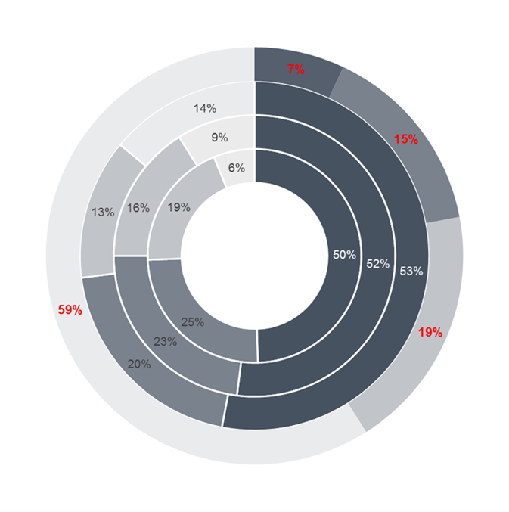
The prevalence of Adverse Childhood Experiences in the sample was greater than is typically found in general population studies. Overall, 93.1% of the sample had experienced at least one Adverse Childhood Experience, rising to 95.4% when bereavement was included and 58.5% (60.8% including bereavement) had experienced four or more Adverse Childhood Experiences (Figure 1).

Inner: CDC-Kaiser (Felitti et al., 1998)

2nd: England (Bellis et al., 2014)

3rd: Wales (Bellis et al., 2015)

Outer: IVY sample (2018)

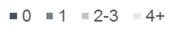
Figure 1. ACE Exposure: IVY compared to key Adverse Childhood Experience studies

Exposure to each individual Adverse Childhood Experience ranged from 18.8% (sexual abuse) to 81.3% (parental separation) as shown in Figure 2 (see also Appendix 1 for full statistical analysis of Adverse Childhood Experience and outcome prevalence). Exposure to parental substance misuse in general was 49.2%, but has been broken down into the constituent parts to enable comparison with the Welsh study (Bellis et al., 2015).
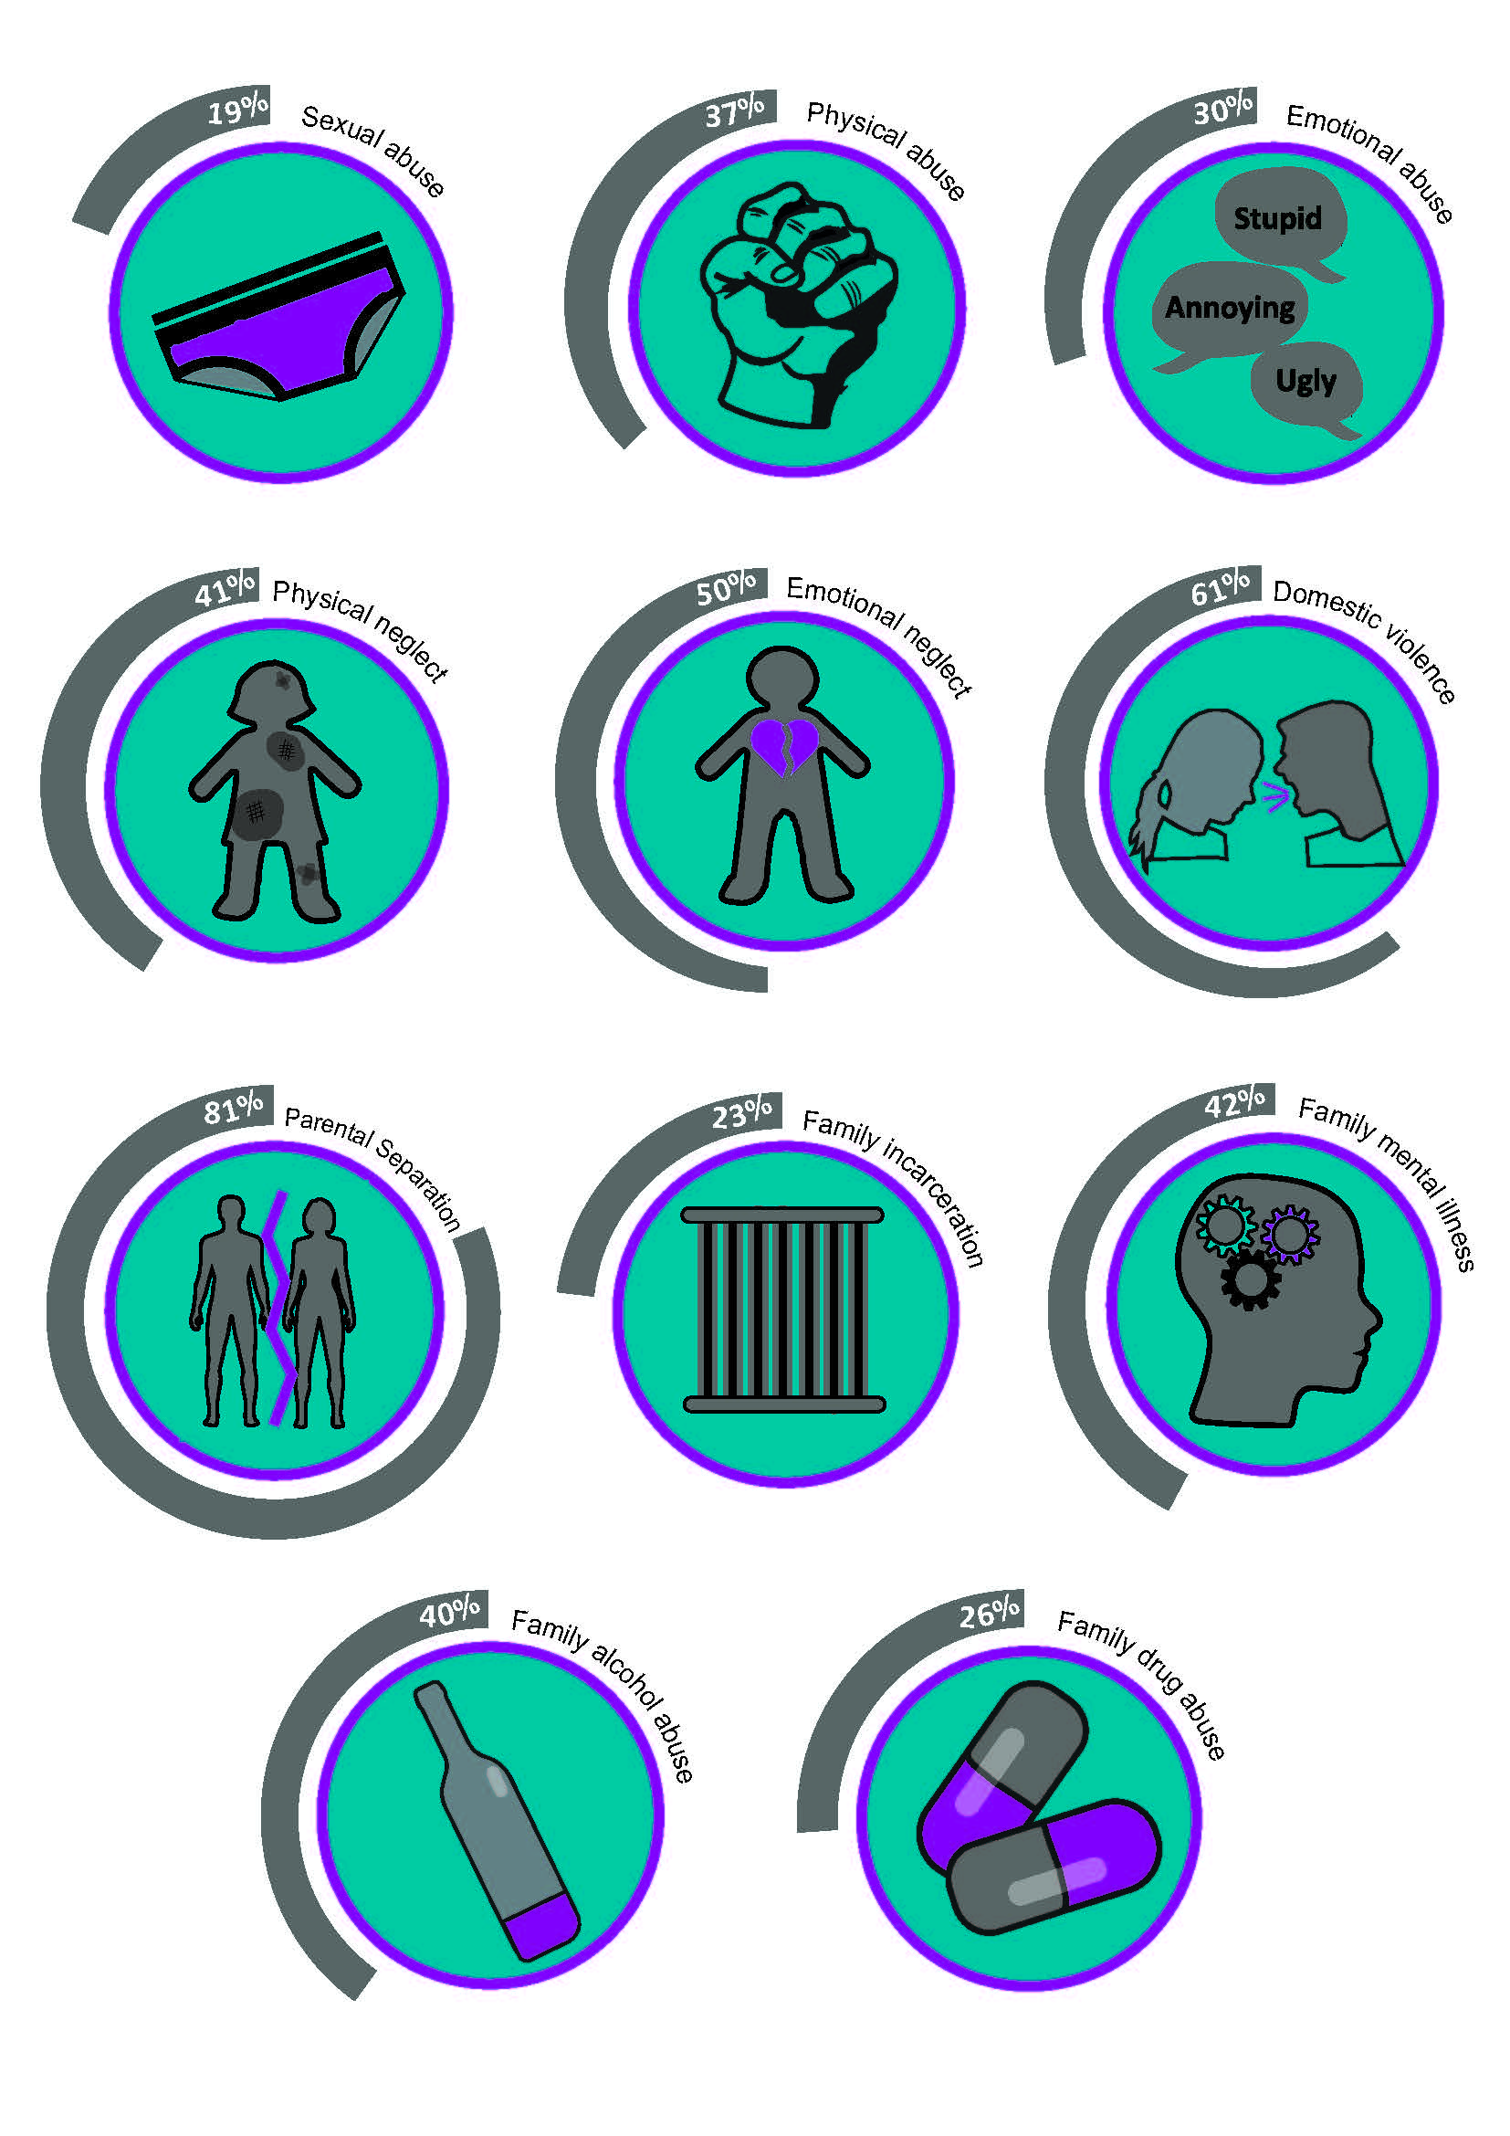Figure 2: Individual Adverse Childhood Experience Exposure in the IVY sample
When compared to the Welsh population study (Bellis et al., 2015) the increased exposure to Adverse Childhood Experiences in the IVY sample is apparent across every individual Adverse Childhood Experience. Notable differences include parental separation, domestic violence and family mental illness (Figure 3).
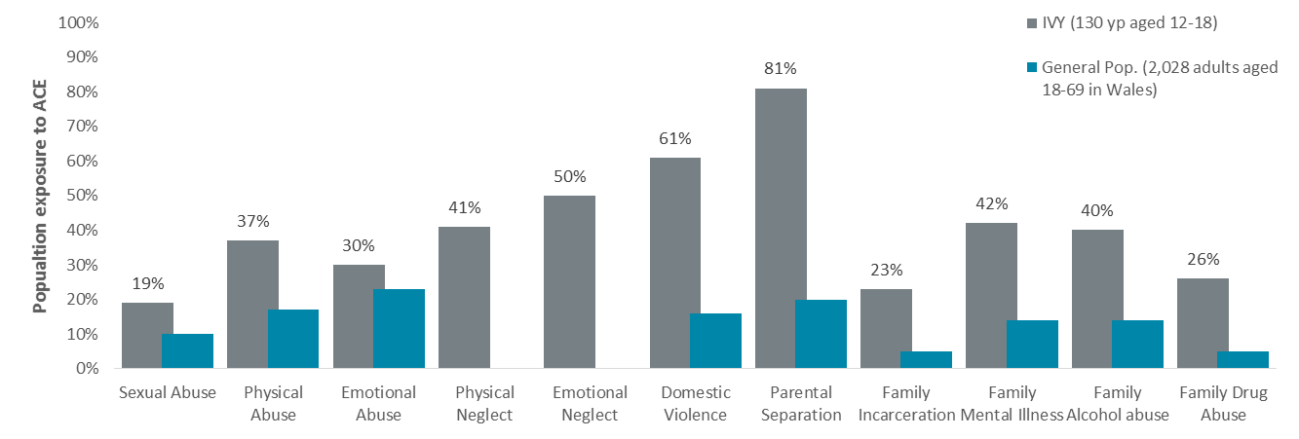
Figure 3: Individual Adverse Childhood Experience Exposure: IVY compared to the Bellis et al. (2015).

Females tended to have a higher rate of exposure to individual Adverse Childhood Experiences, although this only reached significance for sexual abuse, physical abuse, and family incarceration. Males had experienced more exposure to parental separation; mental illness and substance abuse in the family; and bereavement, although differences did not achieve significance (Appendix 1). Females reported a statistically significantly higher composite Adverse Childhood Experience score than males using the ten standard Adverse Childhood Experience categories, with a mean of 4.95 compared to 3.74.

Figure 4: Difference in mean Adverse Childhood Experience exposure between males (n=111) and females (n=19)
This gender difference in overall Adverse Childhood Experience exposure was reduced to the point of no longer being statistically significant when experience of bereavement was included in the Adverse Childhood Experience score (5.11 compared to 4.95). Males were more than twice as likely to have been bereaved as females, and no females reported parental bereavement, compared to 13 males (12.1%).
Relationship to outcomes
The presence of poor outcomes was also a strong feature of the sample, despite their young age. All bar three young people had experienced at least one of the six measured outcomes (97.7%), and almost half of the sample (48.5%) had experienced three or more. Violence towards others was the most common outcome, displayed by 82% of the sample, followed by school exclusion (46.0%) and drug use (45.6%).
Figure 5: Most common measured outcomes in the sample

Females tended to be more likely than males to have experienced each individual outcome, although these differences were not statistically significant (Appendix). The one exception was that males were approximately four times more likely to display harmful sexual behaviour than females, which was a significant difference. There was no difference in the mean number of negative outcomes faced by males and females (Appendix 1).
Unlike in other studies, there was not a clear cut dose-response relationship between the Adverse Childhood Experience categories and poor outcomes. For some outcomes there appeared to be no relationship at all, and for others there was a dose-response relationship that was not statistically significant. Given the high levels of adversity in the sample, Adverse Childhood Experience exposure was then re-categorised into: less than three; three to five; and six or more and the analysis was rerun. Again there was no evidence of a dose-response relationship between the level of Adverse Childhood Experience exposure and negative outcomes. None of the analyses, with or without bereavement included, revealed any statistically significant patterns or associations between Adverse Childhood Experience scores and outcomes although, for reasons of space, the results have not been reported here. There was a slightly increased number of negative outcomes among young people with significant (six or more, as measured in Baglivio et al’s 2014 study of young offenders) exposure to Adverse Childhood Experiences (M=2.9, SD=1.30) compared with young people experiencing five or fewer Adverse Childhood Experiences (M=2.58, SD=1.35) but this difference was not significant (t (128) = -1.302, p= 0.195).

Discussion
The results clearly highlight an extraordinary level of childhood adversity in this small sample of young people who present a high risk of harm to others (as well as to themselves). Overall Adverse Childhood Experience counts, and rates of exposure to each individual Adverse Childhood Experience were notably higher than in general population studies. For example, almost all of the sample (93.1%) had experienced at least one Adverse Childhood Experience, compared to less than half of the population in other UK studies (Bellis et al., 2015; Bellis, Hughes, et al., 2014). The rate of exposure to multiple Adverse Childhood Experiences was also much higher in this sample, with well over half (58.5%) experiencing four or more Adverse Childhood Experiences, compared to 8.3% among English adults (Bellis, Hughes, et al., 2014) and 14% in Wales (Bellis et al., 2015).
Without a comparable Scottish population survey it is difficult to fully assess how much of this observed pattern may be due to the hypothesised association between increased levels of adversity and excess mortality in Scotland (Smith et al., 2016) and what are specific features of this high-risk and vulnerable sample of young people. The overall exposure to Adverse Childhood Experiences is higher than in some adult offender studies such as the 84.4% observed in adult male sex offenders (Levenson et al., 2016); 87.1% of drug-dependent prisoners (Messina, Grella, Burdon, & Prendergast, 2007) and 90.7% of adult males involved in serious offending who required psychological treatment (Reavis et al., 2013). However, other studies involving high-risk young people have found a similar level of adversity, with exposure to at least one Adverse Childhood Experience reaching between 92.6% (Fox et al., 2015) and 97.2% (Baglivio et al., 2014) among serious, violent or chronic offenders in Florida. Other Scottish studies of highly vulnerable young people found similarly levels of adversity, although are not published (Kibble, 2015) or are not able to report on the full range of Adverse Childhood Experiences (Moodie & Wilson, 2017). This potential difference between Adverse Childhood Experience studies involving adults or young people still in childhood may reflect methodological differences in studies (with those involving young people reliant on secondary data rather than self-report); societal, cultural and economic changes over time; or differences among older and younger people in their willingness or ability to accurately recall and disclose adverse childhood experiences.
Unlike other published Adverse Childhood Experience studies there was not an immediately apparent association between increasing Adverse Childhood Experience counts and negative outcomes. This is likely to be a product of a small and skewed sample, in which high levels of adversity were widespread, as well as a level of complexity and multiplicity in the presenting risks and needs which are typically a prerequisite for referral to IVY. Furthermore, the study did not consider longitudinal outcomes, as many participants had not yet reached adulthood and it is possible that other outcomes will emerge throughout the life course. However, in the short-term there also appeared to be remarkable levels of resilience among young people, with those with very high Adverse Childhood Experience exposure (six or more) not found to experience significantly more negative outcomes than those with less exposure to Adverse Childhood Experiences. This finding may also raise questions about the sensitivity of the Adverse Childhood Experience measure, especially at high levels of adversity. Among more vulnerable populations it may be necessary to go beyond the simplicity of the Adverse Childhood Experience count, and consider other factors such as intensity, duration, interactions and relationships (protective and abusive) when thinking about Adverse Childhood Experience exposure. More research is also required to unpick exactly how Adverse Childhood Experiences translate into high-risk behaviours, in order to help support young people and reduce serious offending.
The themes of loss and separation are also prominent in the findings. Parental separation was by far the most prevalent experience; with 81.3% of the sample growing up in households where there had been a documented breakdown in the relationship between biological parents and/or main caregivers. In the UK studies, parental separation was one of the more common childhood experiences, but one that was only experienced by around one-in-five participants (Bellis et al., 2015; Bellis, Hughes, et al., 2014). Furthermore, in this study the way that parental separation was recorded does not reflect the disruption and turmoil that comes with other forms of family breakdown, or with being taken into care. In this small sample, almost three-quarters (71%) of young people were living apart from their birth families, either through formal or informal arrangements. In addition, the prevalence of bereavement, at 34.7%, was lower than has been found in previous studies of other vulnerable young people involved in offending (Vaswani, 2008; Vaswani, 2014). This may, in part, be related to a recording issue, with many of the other Adverse Childhood Experiences routinely documented by IVY as part of the risk formulation process, whereas bereavement is not a specified feature of the assessment process. Thus the level of bereavement and family breakdown reported here is likely to be an underestimate of the true experience of loss and separation in this vulnerable sample. Further research is necessary to more comprehensively document the levels of childhood loss and disruption in the general population and to better understand the complex loss experiences of more vulnerable and marginalised groups. Research of this nature could have important implications for residential childcare policy and practice, by informing how best to safeguard children who face adversity while minimising the impact of system involvement, which paradoxically often creates further loss and adversity.
This research indicates that females comprised a small proportion of referrals to IVY, presumably as a result of lower levels of risk towards others among the female population, but that they presented with a substantial level of childhood adversity and a significantly higher overall Adverse Childhood Experience score than males. This is resonant with other studies of females in more vulnerable populations such as young people involved in offending (Baglivio et al., 2014), in residential and secure care (Kibble, 2015) or in prison (Messina et al., 2007). However, any gender differences in exposure to Adverse Childhood Experiences tend to be small and variable in population-wide studies. Given the potential for underreporting among males, due to a gendered reluctance to disclose sensitive issues or to appear vulnerable (Holmes & Slap, 1999; Levenson et al., 2016; Messina et al., 2007), it can be tentatively assumed that exposure to adversity in childhood is broadly similar among males and females. If this is the case, then why do females, who end up in the justice system, report higher levels of adversity, albeit in much smaller numbers than males?
Rather than indicating a predisposition towards vulnerability among females in general, this finding may suggest that females are more ‘resilient’ than males in the face of childhood adversity. In this study, although females had significantly higher Adverse Childhood Experience scores, there was no corresponding increase in the prevalence of negative outcomes among females. In other studies, Schilling et al. (2007) report that Adverse Childhood Experiences have a stronger effect on both drug use and antisocial behaviour in males than females, with increasing odds occurring at a much lower level of Adverse Childhood Experience exposure in males. For example, boys with four Adverse Childhood Experiences scored one standard deviation higher than boys with no Adverse Childhood Experiences, but for girls it took exposure to 10 Adverse Childhood Experiences before the odds of antisocial behaviour increased by the same amount. Similarly, Fang et al. (2016) found that it took exposure to three times as many Adverse Childhood Experiences for females to increase their HIV risk behaviours to the same level of males. It was also of note that males in this study reported higher levels of loss in relation to both parental separation and bereavement. Importantly, the significant difference in mean Adverse Childhood Experience score between the genders disappeared when bereavement experiences were factored in to the analysis, due to the higher rate of bereavement among males in this sample. Although this on its own was not a significant difference, an earlier analysis (not reported here) of a subset of the sample without any missing data (n=65) did document a significantly higher level of bereavement among males. As it is unlikely that males and females will experience widely different levels of bereavement in childhood, this may indicate that males find dealing with common childhood adversity, such as death or divorce, more difficult than females.
It is not clear whether this is a genuine difference in resilience, such as the existence of more adaptive coping mechanisms or social support; or whether the effect of adversity manifests differently among the genders, with a tendency for females to internalise distress rather than externalise and act out (Baglivio et al., 2014). Either way, it is not inconceivable to see how this could lead to a gendered response from services that is influenced more by an emotional wellbeing and mental health perspective for females, and a behavioural response from authority for males. This could also potentially contribute towards an explanation of the overrepresentation of males in the criminal justice system, but also help understand why the females that come into contact with formal systems tend to be highly vulnerable and victimised. However, it is not possible to fully unpick these gender differences from the data presented here. Further research in a more normative sample is needed in order to better understand how the different genders respond to adversity. This would help inform how the system can respond at the earliest possible time and in the most appropriate manner to ensure that all young people, but males in particular, are not criminalised and punished for their exposure to adversity.

References
Akerman, R., & Statham, J. (2014). Bereavement in childhood: the impact on psychological and educational outcomes and the effectiveness of support services. London: Child Wellbeing Research Centre and the Institute of Education.
Anda, R. F., Whitfield, C. L., Felitti, V. J., Chapman, D., Edwards, V. J., Dube, S. R., & Williamson, D. F. (2002). Adverse childhood experiences, alcoholic parents, and later risk of alcoholism and depression. Psychiatric services, 53(8), 1001-1009.
Baglivio, M. T., Epps, N., Swartz, K., Huq, M. S., Sheer, A., & Hardt, N. S. (2014). The prevalence of adverse childhood experiences (ACE) in the lives of juvenile offenders. Journal of juvenile justice, 3(2), 1.
Baglivio, M. T., Wolff, K. T., Piquero, A. R., & Epps, N. (2015). The relationship between adverse childhood experiences (ACE) and juvenile offending trajectories in a juvenile offender sample. Journal of Criminal Justice, 43(3), 229-241.
Bellis, M., Ashton, K., Hughes, K., Ford, K., Bishop, J., & Paranjothy. (2015). Adverse childhood experiences and their impact on health-harming behaviours in the Welsh adult population. Cardiff: Public Health Wales Retrieved from http://www2.nphs.wales.nhs.uk:8080/PRIDDocs.nsf/7c21215d6d0c613e80256f490030c05a/d488a3852491bc1d80257f370038919e/$FILE/ACE%20Report%20FINAL%20(E).pdf.
Bellis, M., Hughes, K., Leckenby, N., Perkins, C., & Lowey, H. (2014). National household survey of adverse childhood experiences and their relationship with resilience to health-harming behaviors in England. BMC medicine, 12(1), 72.
Bellis, M., Lowey, H., Leckenby, N., Hughes, K., & Harrison, D. (2014). Adverse childhood experiences: retrospective study to determine their impact on adult health behaviours and health outcomes in a UK population. Journal of Public Health, 36(1), 81-91.
Borum, R., Bartel, P., & Forth, A. (2002). SAVRY: Manual for the structured assessment of violence risk in youth Tampa. FL: Florida Mental Health Institute, University of South Florida.
Brown, D. W., Anda, R. F., Felitti, V. J., Edwards, V. J., Malarcher, A. M., Croft, J. B., & Giles, W. H. (2010). Adverse childhood experiences are associated with the risk of lung cancer: a prospective cohort study. BMC Public Health, 10(1), 20. doi: 10.1186/1471-2458-10-20
Brown, D. W., Anda, R. F., Tiemeier, H., Felitti, V. J., Edwards, V. J., Croft, J. B., & Giles, W. H. (2009). Adverse Childhood Experiences and the Risk of Premature Mortality. American Journal of Preventive Medicine, 37(5), 389-396. doi: https://doi.org/10.1016/j.amepre.2009.06.021
Chapman, D. P., Whitfield, C. L., Felitti, V. J., Dube, S. R., Edwards, V. J., & Anda, R. F. (2004). Adverse childhood experiences and the risk of depressive disorders in adulthood. J Affect Disord, 82. doi: 10.1016/j.jad.2003.12.013
Couper, S., & Mackie, P. (2016). Scottish Public Health Network (ScotPHN).
Dong, M., Anda, R. F., Felitti, V. J., Dube, S. R., Williamson, D. F., Thompson, T. J., . . . Giles, W. H. (2004). The interrelatedness of multiple forms of childhood abuse, neglect, and household dysfunction. Child abuse & neglect, 28, 771-784. doi: 10.1016/j.chiabu.2004.01.008
Dong, M., Dube, S. R., Felitti, V. J., Giles, W. H., & Anda, R. F. (2003). Adverse childhood experiences and self-reported liver disease: New insights into the causal pathway. Archives of Internal Medicine, 163(16), 1949-1956. doi: 10.1001/archinte.163.16.1949
Dube, S. R., Felitti, V. J., Dong, M., Chapman, D. P., Giles, W. H., & Anda, R. F. (2003). Childhood abuse, neglect, and household dysfunction and the risk of illicit drug use: the adverse childhood experiences study. Pediatrics, 111(3), 564-572.
Dube, S. R., Miller, J. W., Brown, D. W., Giles, W. H., Felitti, V. J., Dong, M., & Anda, R. F. (2006). Adverse childhood experiences and the association with ever using alcohol and initiating alcohol use during adolescence. Journal of Adolescent Health, 38(4), 444.e441-444.e410. doi: https://doi.org/10.1016/j.jadohealth.2005.06.006
Fang, L., Chuang, D.-M., & Lee, Y. (2016). Adverse childhood experiences, gender, and HIV risk behaviors: Results from a population-based sample. Preventive medicine reports, 4, 113-120.
Fauth, B., Thompson, M., & Penny, A. (2009). Associations between childhood bereavement and children’s background, experiences and outcomes. London: National Children’s Bureau.
Felitti, V. J., Anda, R. F., Nordenberg, D., Williamson, D. F., Spitz, A. M., Edwards, V., . . . Marks, J. S. (1998). Relationship of Childhood Abuse and Household Dysfunction to Many of the Leading Causes of Death in Adults: The Adverse Childhood Experiences (ACE) Study. American Journal of Preventive Medicine, 14, 245-258. doi: 10.1016/S0749-3797(98)00017-8
Finlay, I. G., & Jones, N. K. (2000). Unresolved grief in young offenders in prison. The British journal of general practice : the journal of the Royal College of General Practitioners, 50, 569-570.
Fox, B. H., Perez, N., Cass, E., Baglivio, M. T., & Epps, N. (2015). Trauma changes everything: Examining the relationship between adverse childhood experiences and serious, violent and chronic juvenile offenders. Child abuse & neglect, 46, 163-173.
Hardt, J., & Rutter, M. (2004). Validity of adult retrospective reports of adverse childhood experiences: review of the evidence. Journal of Child Psychology and Psychiatry, 45(2), 260-273. doi: 10.1111/j.1469-7610.2004.00218.x
Harrison, L., & Harrington, R. (2001). Adolescents' bereavement experiences. Prevalence, association with depressive symptoms, and use of services. Journal of adolescence, 24, 159-169. doi: 10.1006/jado.2001.0379
Hillis, S. D., Anda, R. F., Dube, S. R., Felitti, V. J., Marchbanks, P. A., & Marks, J. S. (2004). The Association Between Adverse Childhood Experiences and Adolescent Pregnancy, Long-Term Psychosocial Consequences, and Fetal Death. Pediatrics, 113(2), 320-327. doi: 10.1542/peds.113.2.320
Holmes, W. C., & Slap, G. B. (1999). Sexual abuse of boys: Definition, prevalence, correlates, sequelae, and management. Journal of the American Academy of Child & Adolescent Psychiatry, 38(5), 631-632.
Kibble. (2015). Profile of Young People at Kibble. Paisley: Kibble Education and Care Centre.
Levenson, J. S., Willis, G. M., & Prescott, D. S. (2016). Adverse childhood experiences in the lives of male sex offenders: Implications for trauma-informed care. Sexual Abuse, 28(4), 340-359.
Messina, N., Grella, C., Burdon, W., & Prendergast, M. (2007). Childhood Adverse Events and Current Traumatic Distress. Criminal Justice and Behavior, 34(11), 1385-1401. doi: doi:10.1177/0093854807305150
Moodie, K., & Wilson, G. (2017). Strengths, needs and adverse childhood experiences in young women at high risk. Glasgow: Centre for Youth and Criminal Justice.
Parsons, S. (2011). Long-term impact of childhood bereavement. Preliminary analysis of the 1970 British Cohort Study (BCS70). London: Childhood Wellbeing Research Centre.
Reavis, J. A., Looman, J., Franco, K. A., & Rojas, B. (2013). Adverse childhood experiences and adult criminality: How long must we live before we possess our own lives? The Permanente Journal, 17(2), 44.
Redford, J. (Writer). (2016). Resilience. In KPJR Films (Producer). USA.
Schilling, E. A., Aseltine, R. H., & Gore, S. (2007). Adverse childhood experiences and mental health in young adults: a longitudinal survey. BMC Public Health, 7(1), 30.
Smith, M., Williamson, A. E., Walsh, D., & McCartney, G. (2016). Is there a link between childhood adversity, attachment style and Scotland’s excess mortality? Evidence, challenges and potential research. BMC Public Health, 16(1), 655. doi: 10.1186/s12889-016-3201-z
Vaswani, N. (2008). Persistent Offender Profile: Focus on Bereavement CJSW Briefing Paper 13: August 2008, Edinburgh.
Vaswani, N. (2014). The Ripples of Death: Exploring the Bereavement Experiences and Mental Health of Young Men in Custody. The Howard Journal of Criminal Justice, 53(4), 341-359. doi: 10.1111/hojo.12064

Appendix 1
Table 1. ACE Exposure by gender
 | Individual ACEs |  |  |  |  |  |  |  |  |  | Potential ACES | Overall ACE Exposure
 | Abuse |  |  | Neglect |  | Household Dysfunction |  |  |  |  | Bereavement | Without | With
 | Sexual | Physical | Emotional | Physical | Emotional | Domestic Violence | Parental Separation | Incarcer-ation | Mental Illness | Substance Abuse | Significant Bereavement | bereavement  M SD | bereavement  M SD
Prevalence % ª | 18.8 | 36.5 | 30.4 | 40.7 | 50.4 | 60.9 | 81.3 | 22.8 | 41.6 | 49.2 | 34.7 | 3.92 2.385 | 4.24 2.436
Gender
Male | 13.8 | 31.3 | 27.8 | 40.2 | 47.0 | 60.2 | 82.6 | 19.0 | 42.1 | 50.5 | 37.9 | 3.74 2.271 | 4.09 2.345
Female | 50.0 | 63.2 | 44.4 | 43.8 | 70.6 | 64.7 | 73.7 | 44.4 | 38.9 | 42.1 | 16.7 | 4.95 2.818 | 5.11 2.410
χ ² or t ^{b} | 8.116 | 5.657 | 1.272 | 0.000 | 2.359 | 0.006 | 0.357 | 4.285 | 0.000 | 0.178 | 2.175 | -2.066 | -1.690
p | <0.01 | <0.05 | 0.259 | 1.000 | 0.125 | 0.937 | 0.352 | <0.05 | 1.000 | 0.673 | 0.140 | <0.05 | 0.093
ª When missing data is excluded n varies from 101 (Sexual Abuse) to 128 (Parental Separation). Means rather than % are reported for Overall ACE Exposure
^{b} For mean ACE exposure, t is reported from an independent samples t-test

Table 2. Outcome by gender
 | Individual negative outcomes |  |  |  |  |  | Total negative outcomes
 | Alcohol use | Drug Use | Violent behaviour | Harmful sexual behaviour | Secure care / custody | School exclusion | M | SD
Prevalence % ª | 41.1 | 45.6 | 82.0 | 37.5 | 26.6 | 46.0 | 2.68 | 1.335
Gender
Male | 38.1 | 42.5 | 81.7 | 42.6 | 25.7 | 47.6 | 2.66 | 1.372
Female | 57.9 | 63.2 | 84.2 | 10.5 | 31.6 | 36.8 | 2.84 | 1.119
χ ² or t ^{b} | 1.851 | 2.012 | 0.000 | 5.707 | 0.065 | 0.381 | 0.555
p | 0.174 | 0.156 | 1.000 | <0.05 | 0.799 | 0.537 | 0.580
ª When missing data is excluded n varies from 120 (Harmful Sexual Behaviour) to 128 (violent behaviour and secure care / custody). Means rather than % are reported for total negative outcomes
^{b} For total negative outcomes, t is reported from an independent samples t-test

